**Problem Statement 1:** A Program to illustrate Order List and Unordered List in a proper way.

**Aim:** To display list items on browser with the help of <ul> and <ol> tags and their different types.

**Code:**

<!DOCTYPE html>

<html lang="en">

<head>

<title>Question 1

</title>

</head>

<body>

<h4>Unordered List Default</h4>

<ul>

<li>Apple</li>

<li>Mango</li>

<li>Banana</li>

</ul>

<hr>

<h4>Un-Ordered List with List Items as Circle</h4>

<ul type='Circle'>

<li>Apple</li>

<li>Mango</li>

<li>Banana</li>

</ul>

<hr>

<h4>Un-Ordered List with List Items as Square</h4>

<ul type='Square'>

<li>Apple</li>

<li>Mango</li>

<li>Banana</li>

</ul>

<hr>

<h4>Un-Ordered List with List Items marked as None</h4>

<ul type='None'>

<li>Apple</li>

<li>Mango</li>

<li>Banana</li>

</ul>

<hr>

<h4>Ordered List Default</h4>

<ol>

<li>Apple</li>

<li>Mango</li>

<li>Banana</li>

</ol>

<hr>

<h4>Ordered List with Upper Case of List Items</h4>

<ol type="A">

<li>Apple</li>

<li>Mango</li>

<li>Banana</li>

</ol>

<hr>

<h4>Ordered List with Lower Case of List Items</h4>

<ol type="a">

<li>Apple</li>

<li>Mango</li>

<li>Banana</li>

</ol>

<hr>

<h4>Ordered List with Roman Number of List Items</h4>

<ol type="i">

<li>Apple</li>

<li>Mango</li>

<li>Banana</li>

</ol>

<hr>

<h4>Description List</h4>

<dl>

<dt><b>Apple</b></dt>

<dd>A red colored fruit</dd>

<dt><b>Honda</b></dt>

<dd>A brand of a car</dd>

<dt><b>Spinach</b></dt>

<dd>A green leafy vegetable</dd>

</dl>

<hr>

<h4>Nested Ordered List</h4>

<ol>

<li>Banana</li>

<li> Apple

<ol>

<li>Green Apple</li>

<li>Red Apple</li>

</ol>

</li>

<li>Pineapple</li>

<li>Orange</li>

</ol>

<hr>

<h4>Nested Un-Ordered List</h4>

<ul>

<li>Fruits</li>

<ul>

<li>Apple</li>

<li>Banana</li>

<li>Mango</li>

<li>Orange</li>

</ul>

<li>Vegetables</li>

<ul>

<li>Spinach</li>

<li>Cauliflower</li>

<li>Beetroot</li>

</ul>

<li>Cereals</li>

<li>Nuts</li>

</ul>

</body>

</html>

**Output :**

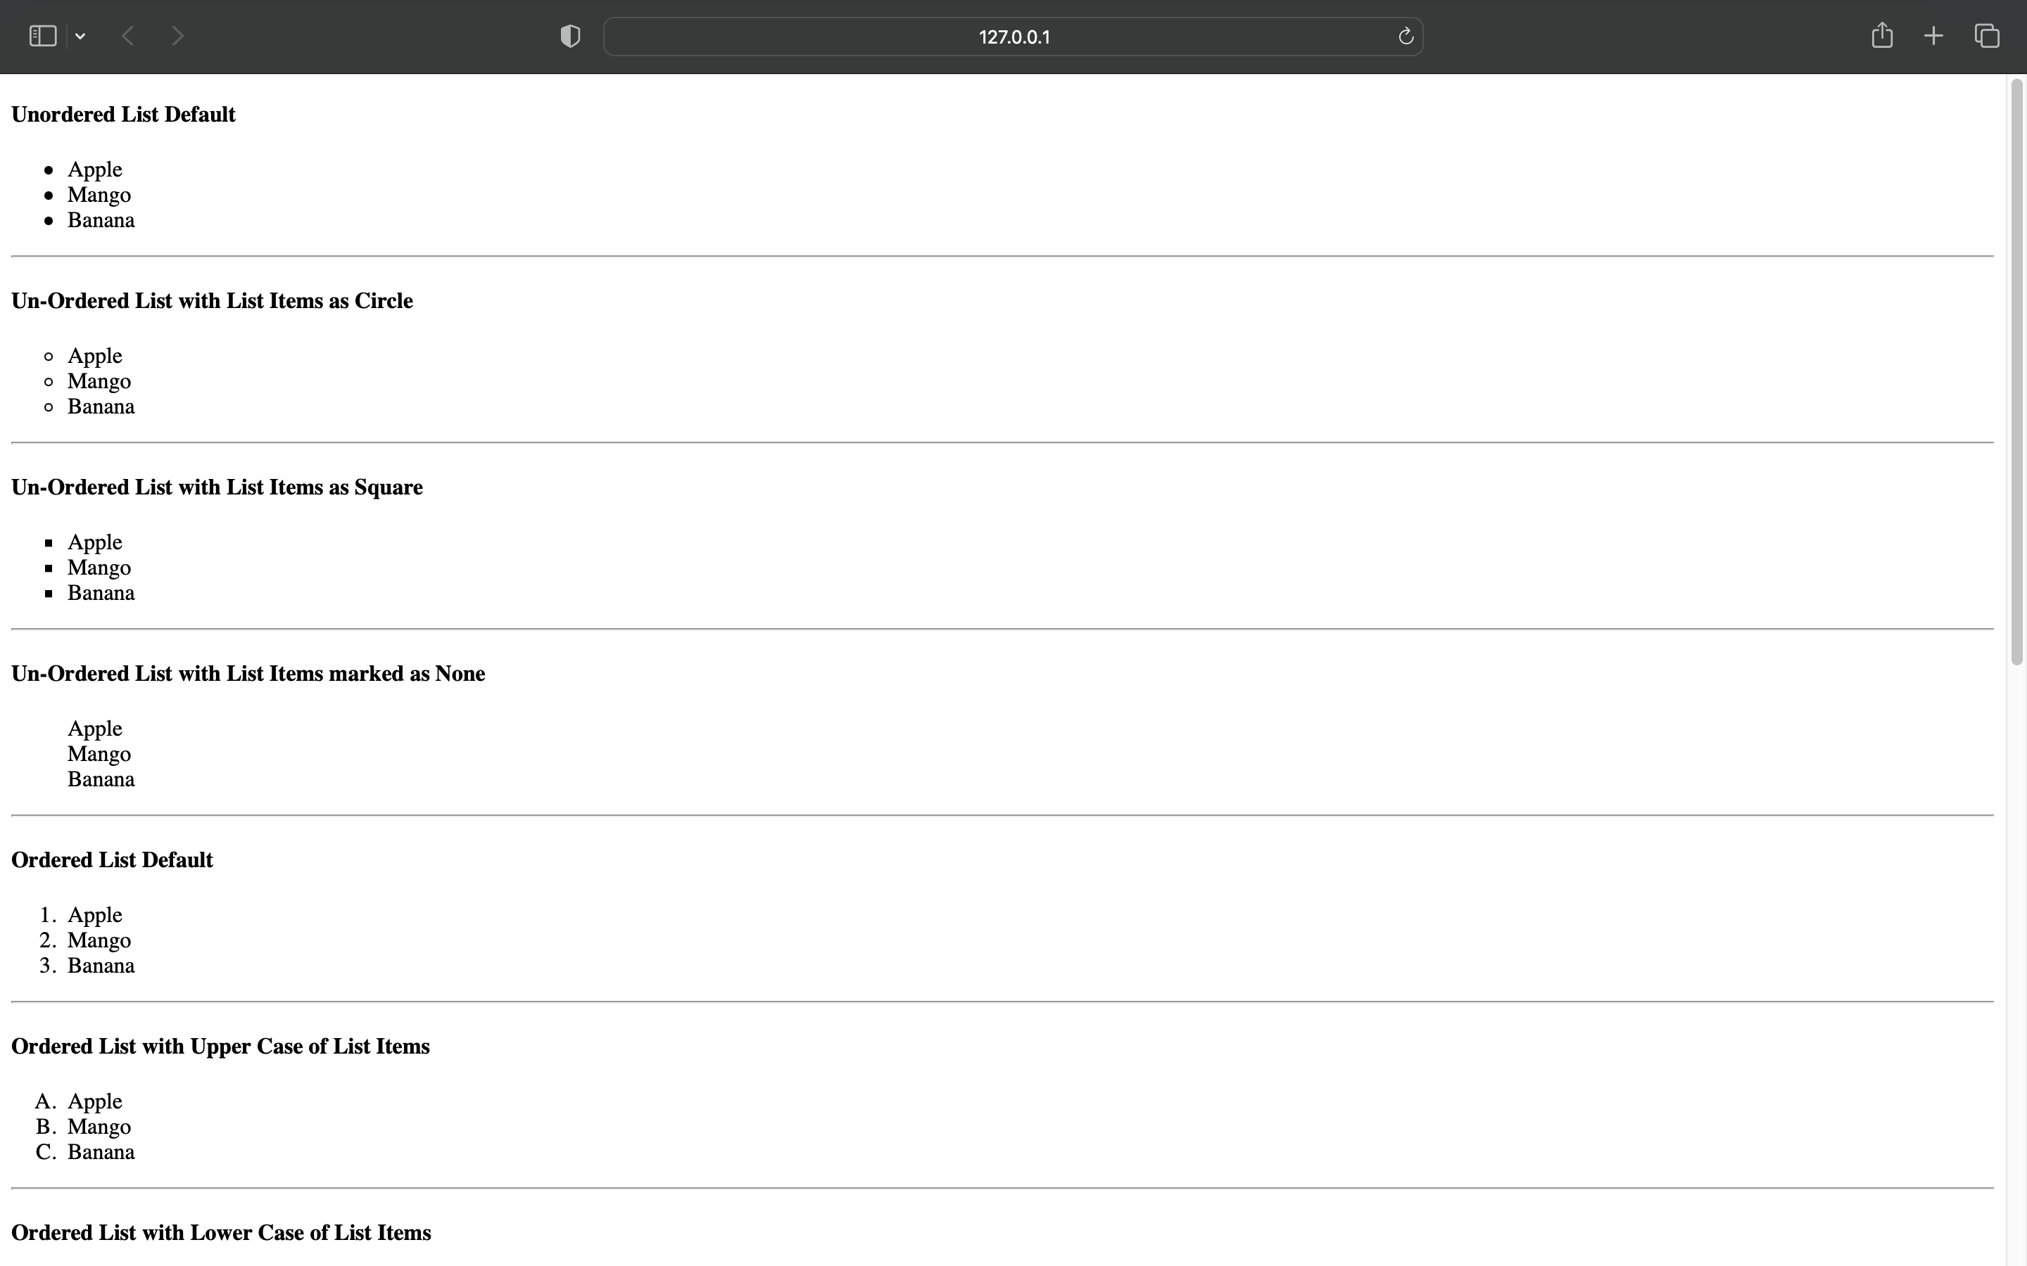

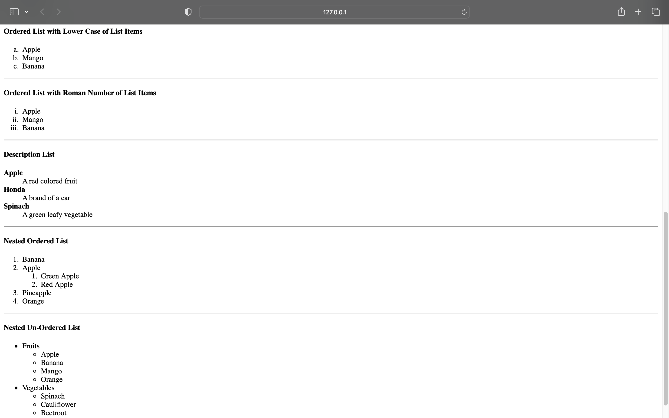

**Problem Statement 2:** A Program to illustrate Img tag, and Hyper Link tag in a proper way and make clickable image

**Aim:** To display Image on browser with hyperlink property using anchor tag that navigates user to new page/file after clicking it.

**Code:**

<!DOCTYPE html>

<html lang="en">

<head>

<title>Document</title>

</head>

<body>

<h2>Click on the Logo image Below to open GEU Website...</h2><br><br>

<a href="https://www.geu.ac.in"><img

src="geu-logo.svg"></a> </body>

</html>

Output :





**Problem Statement 3:** A Program to illustrate current semester time table using table tag.

**Aim:** To display the Time-Table on browser in proper format using <table> tag.

**Code:**

<!DOCTYPE html>

<html lang="en">

<head>

<title>Question 3</title>

</head>

<body>

<html>

<head>

<title> Time Table </title>

</head>

<style>

#nn{

font-weight: bold;

padding: 5px;

}

#nw{

padding:5px;

}

</style>

<body>

<h1 align=center>Time Table </h1>

<table border=1 width=100%>

<tr id="nn">

<td>Days / Time</td>

<td>8:00-9:00</td>

<td>9:00-10:00</td>

<td>10:00-11:00</td>

<td>11:00-12:00</td>

<td>12:00-1:00</td>

<td>1:00-2:00</td>

<td>2:00-3:00</td>

<td>3:00-4:00</td>

<td>4:00-5:00</td>

<td>5:00-6:00</td>

</tr>

<tr>

<td id="nn">Monday</td>

<td>Seminar</td>

<td>Library</td>

<td>Sports</td>

<td>NPTL</td>

<td rowspan=6 align=center>LUNCH</td>

<td colspan=2>TBI 501 Anand Kumar</td>

<td>TBI 503 Anuj Singh</td>

<td colspan=2>Project Lab</td>

</tr>

<tr>

<td id="nn">Tuesday</td>

<td>Library</td>

<td>Sports</td>

<td>Seminar</td>

<td>NPTL</td>

<td> </td>

<td>TBI 501 Anand Kumar</td>

<td colspan="3">Project LAB</td>

</tr>

<tr>

<td id="nn">Wednesday</td>

<td>NPTL</td>

<td>Sports</td>

<td>Seminar</td>

<td>Library</td>

<td> </td>

<td>TBI 503 Anuj Singh</td>

<td>TBI 501 Anand Kumar</td>

<td>TBI 502 Harendra Negi</td>

<td> </td>

</tr>

<tr>

<td id="nn">Thursday</td>

<td>Seminar</td>

<td>Sports</td>

<td>Library</td>

<td>NPTL</td>

<td>TBI 504 Richa Alagh</td>

<td>TBI 503 Anuj Singh</td>

<td>TBI 501 Anand Kumar</td>

<td>LIB</td>

<td>TBI 502 Harendra Negi</td>

</tr>

<tr>

<td id="nn">Friday</td>

<td>NPTL</td>

<td>Sports</td>

<td>Library</td>

<td>Seminar</td>

<td> </td>

<td>TBI 504 Richa Alagh</td>

<td>TBI 503 Anuj Singh</td>

<td>TBI 501 Anand Kumar</td>

<td>LIB</td>

</tr>

<tr>

<td id="nn">Saturday</td>

<td>NPTL</td>

<td>Seminar</td>

<td>Sports</td>

<td>Library</td>

<td colspan=5 align=center>Sports</td>

</tr>

</table>

<br><br><br>

<table border="1" id="nw">

<tr id="nn">

<td>Subject Code</td>

<td>Subject Name</td>

<td>Faculty</td>

</tr>

<tr>

<td> TBI 501 </td>

<td> Programming in C# .Net </td>

<td> Prof. Anand Kumar </td>

</tr>

<tr>

<td> TBI 502 </td>

<td> Full Stack Development </td>

<td> Mr. Harendra Singh Negi </td>

</tr>

<tr>

<td> TBI 503 </td>

<td> Distributed Systems </td>

<td> Mr. Anuj Singh </td>

</tr>

<tr>

<td> TBI 504 </td>

<td> Career Skills II </td>

<td> Ms. Richa Alagh </td>

</tr>

<td id="nn"colspan=3>LAB</td>

<tr>

<td> PBI 501 </td>

<td> Full Stack Development & python Lab </td>

<td> Mr. Harendra Singh Negi </td>

</tr>

<tr>

<td> TBI 502 </td>

<td> Programming in C# .Net LAB </td>

<td> Prof. Anand Kumar </td>

</tr>

</table>

</body>

</html>

Output :

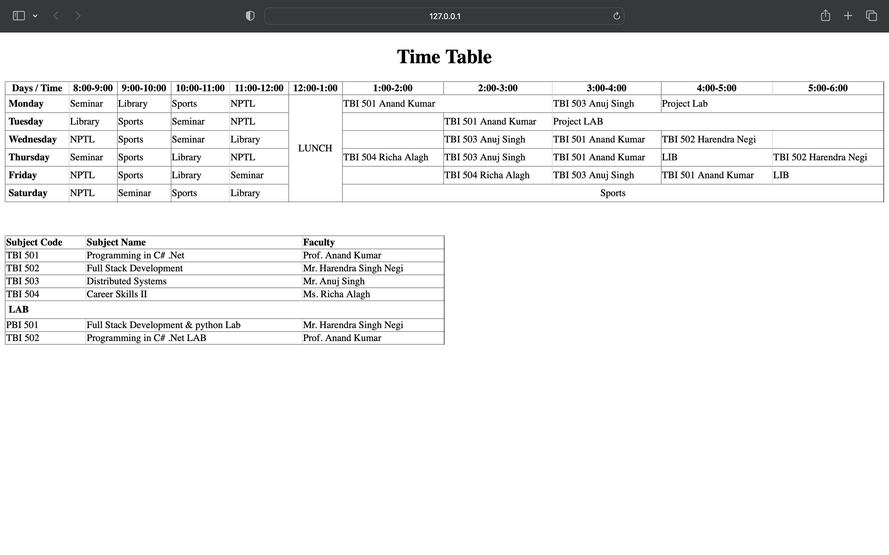

**Problem Statement 4:** A Program to illustrate frameset by dividing the screen according to your requirement and display a complete webpage in a proper format.

**Aim:** To show different websites on same page by dividing screen into multiple sections using <frameset> and frames.

**Code:**

<!DOCTYPE html>

<html lang="en">

<head>

<meta charset="UTF-8">

<meta http-equiv="X-UA-Compatible" content="IE=edge">

<meta name="viewport" content="width=device-width, initial-scale=1.0">

<title>Document</title>

</head>

<frameset rows="10%,80%,10%">

<frame name='a' src="a.html">

<frameset cols="20%,60%,20%">

<frame name='b' src="b.html">

<frame name='c' src="c.html">

<frame name='e' src="e.html">

</frameset>

<frame name='d' src="d.html">

</frameset>

</html>

Output :

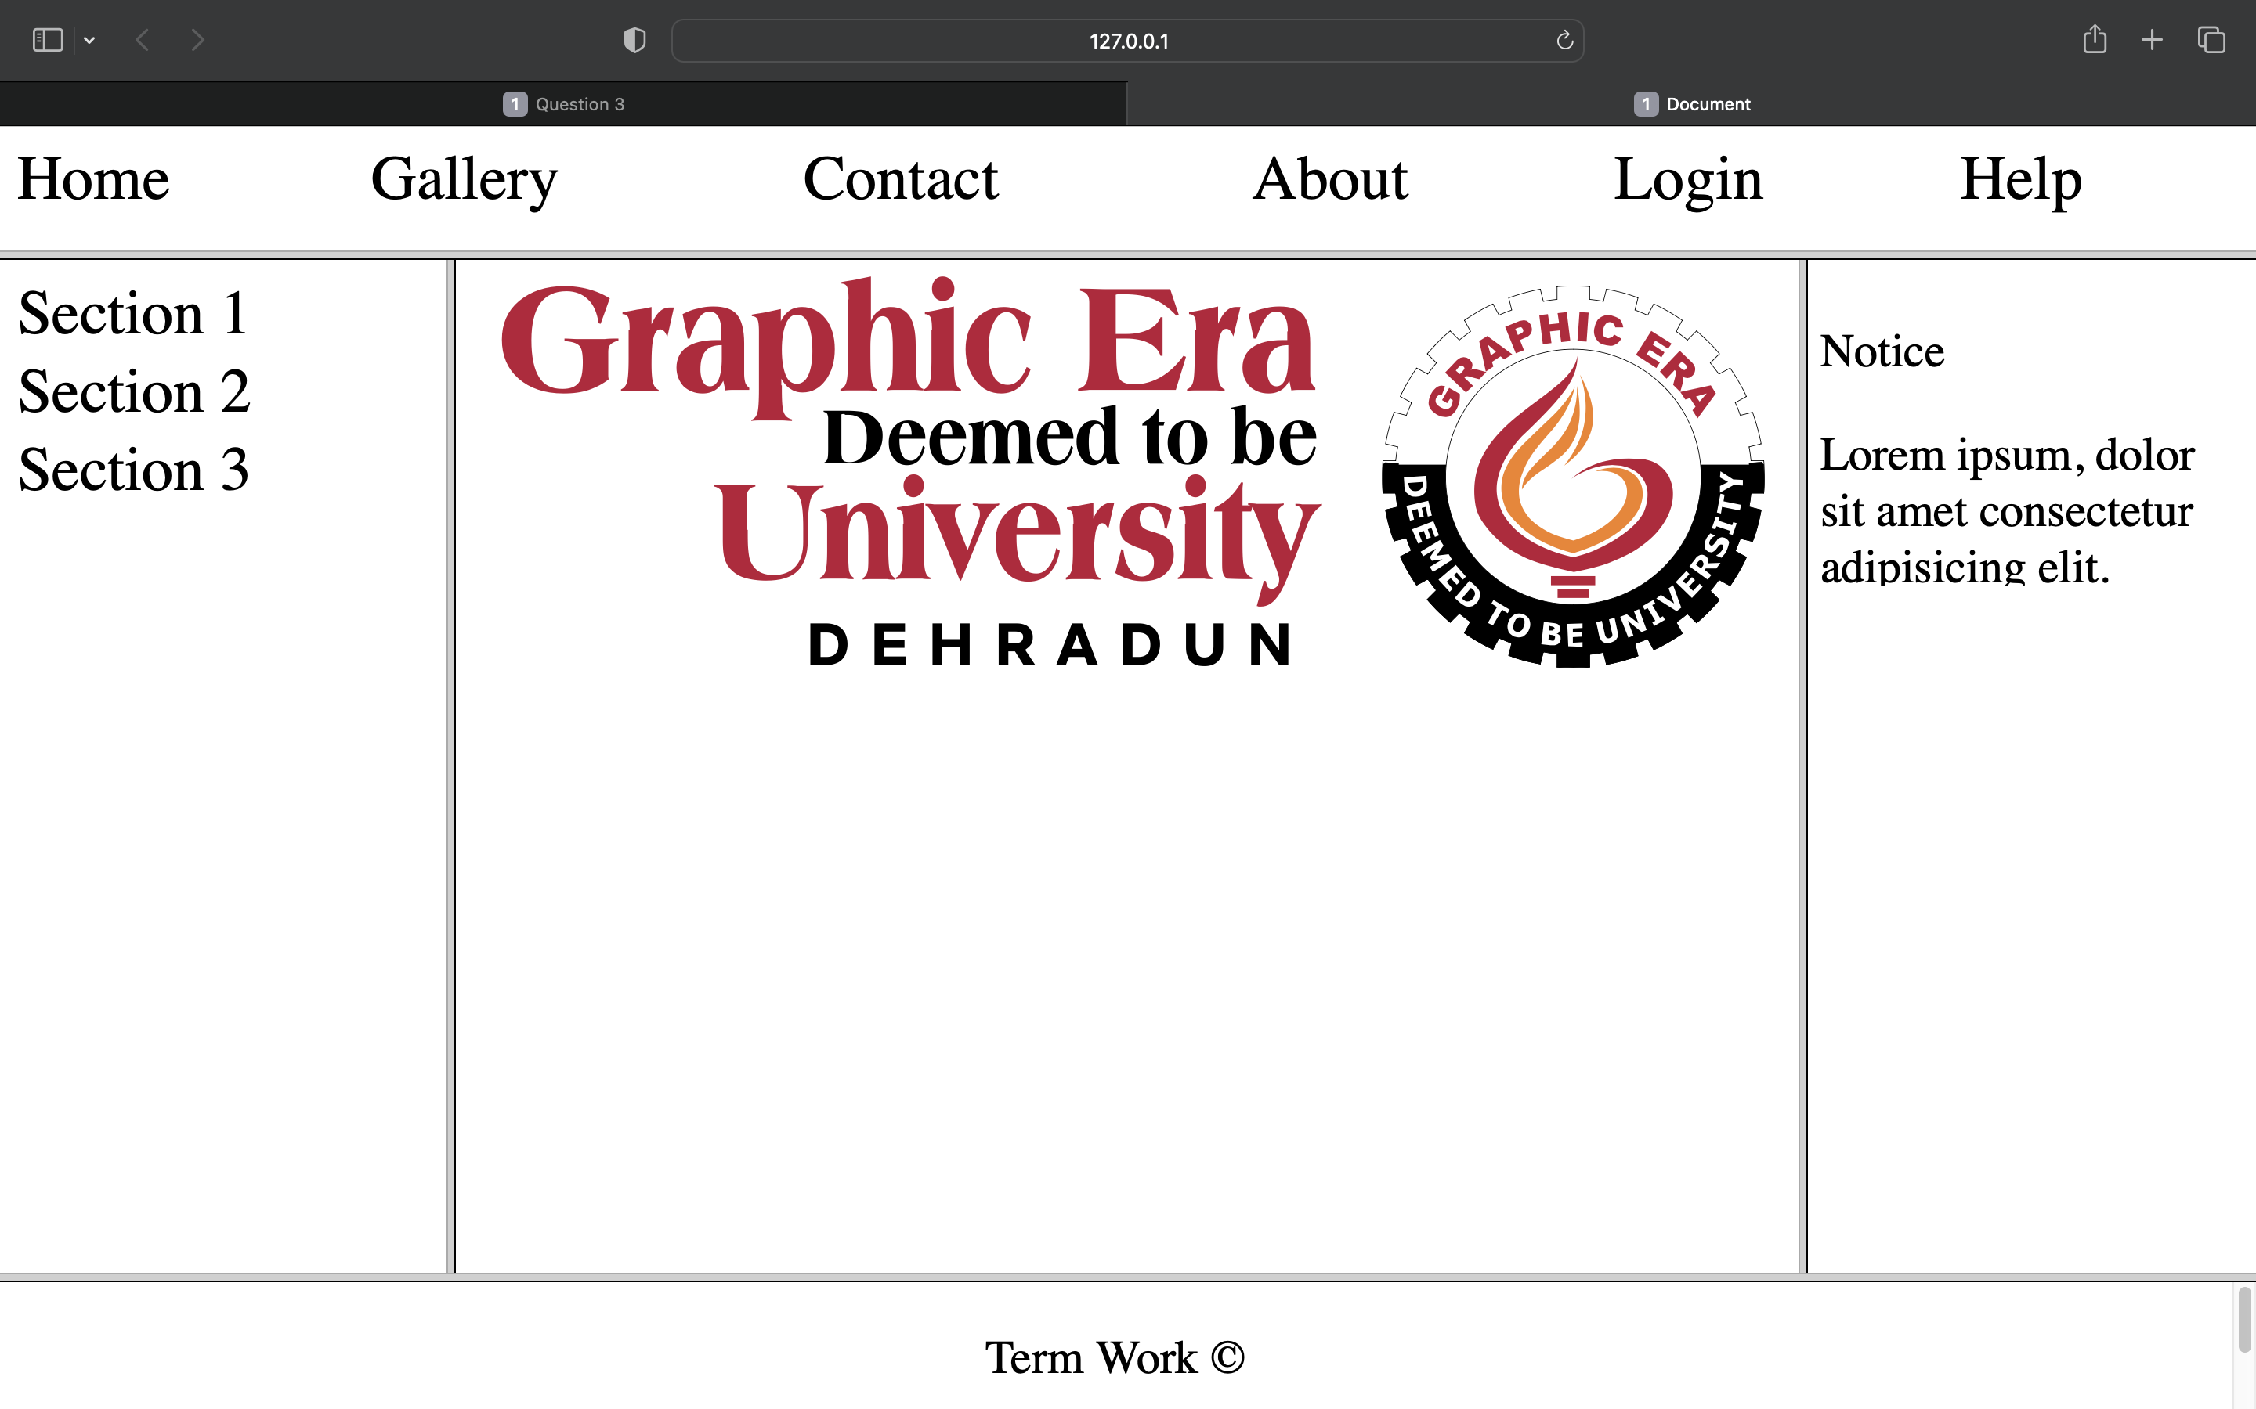

**Problem Statement 5:** A Program to illustrate graphic era university enquiry form using form tag and input controls.

**Aim:** To display an enquiry form web using HTML forms and inputs and basic HTML tags.

**Code:**

<!DOCTYPE html>

<html lang="en">

<head>

<meta charset="UTF-8">

<meta http-equiv="X-UA-Compatible" content="IE=edge">

<meta name="viewport" content="width=device-width, initial-scale=1.0">

<title>Document</title>

</head>

<style>

*{

font-size: 18px;

}

input[type=text]{

width: 100%;

border: 1px solid black;

}

td{

padding: 5px;

}

#heading{

color:darkmagenta;

font-size: 40px;

font-weight: bold;

}

#dt{

align: right;

}

#geu{

color: #5c8be3;

float: left;

font-size: 50px;

font-weight: bold;

}

#aleft{

float:inline-end;

font-size: 25px;

color: grey;

}

</style>

<body><div>

<span id="geu">Graphic Era </span> <img src="geu.png" height="60px" width="60px">

<span id="aleft">CELEBRATING 25 YEARS</span></div>

<hr>

<div>

<span id="heading">ENQUIRY FORM </span><span> USE CAPITAL LETTERS ONLY</span><span id="aleft"> Date: _______</span></div>

<hr>

<table width="100%">

<tr>

<td><label>1.Candidates Name : </label></td>

<td colspan="3"><input type="text"></td>

</tr>

<tr>

<td><label>2.Father's Name : </label></td>

<td colspan="3"><input type="text"></td>

</tr>

<tr>

<td><label>3.Gender : </label></td>

<td>Male<input type="checkbox"> Female <input type="checkbox"></td>

</tr>

<tr>

<td><label>4.Address for Correspondence : </label></td>

<td colspan="3"><input type="text"></td>

</tr>

<tr>

<td><label>Father's Phone Number : </label></td>

<td><input type="text"></td>

<td><label>Student's Phone Number : </label>

<td><input type="text"></td>

</tr>

<tr>

<td><label>5.Student's Email Address : </label></td>

<td colspan="3"><input type="text"></td>

</tr>

<tr>

<td><label>6.Parent's Email Address : </label></td>

<td colspan="3"><input type="text"></td>

</tr>

</table>

<table border="1px" width="100%">

<tr align="center">

<td>Class</td>

<td>Exam Passed / Appearing</td>

<td>Board /University </td>

<td>Year</td>

<td>Percentage(%)</td>

</tr>

<tr>

<td>10th</td>

<td> </td>

<td> </td>

<td> </td>

<td> </td>

</tr>

<tr>

<td>12th</td>

<td> </td>

<td> </td>

<td> </td>

<td> </td>

</tr>

<tr>

<td>Graduation</td>

<td> </td>

<td> </td>

<td> </td>

<td> </td>

</tr>

<tr>

<td>Others</td>

<td> </td>

<td> </td>

<td> </td>

<td> </td>

</tr>

</table>

<table>

<tr>

<td><label>8.Program Intrested In : </label></td>

<td colspan="3"><input type="text"></td>

</tr>

<tr>

<td><label>9.Campus Choice : </label></td>

<td>GEU Dehradun<input type="checkbox"></td><td> GEHU Dehradun <input type="checkbox"></td> <td>Bhimtal <input type="checkbox"></td></td>

</tr>

<tr>

<td><label>10.Entrance Exam Appeared (CAT/MAT | JEE MAINS):

</label></td>

<td colspan="3"> </td>

</tr>

<tr>

<td><label>Roll No : </label></td>

<td><input type="text"></td>

<td><label>Score / Percentile : </label>

<td><input type="text"></td>

</tr>

<tr>

<td><label>10.How did you come to know about Graphic Era University? (Tick Appropiate Box) </label></td></tr>

<tr>

<td>Print Media<input type="checkbox"></td><td> Digital Media <input type="checkbox"></td> <td>Electronic Media <input type="checkbox"></td></td>

</tr>

<tr>

<td><label>Any Other Source : </label></td>

<td colspan="3"><input type="text"></td>

</tr>

<tr>

<td> </td>

</tr>

<tr>

<td colspan="3"></td>

<td><label>Student's Signature : ____________ </label></td>

</tr>

</table>

<hr>

<table width="100%">

<tr>

<td><label>For Office Use : </label><input type="text"></td>

<td><label>Office Name : </label> <input type="text"></td>

</tr>

<tr>

<td><label>Remarks : </label></td></tr>

<tr>

<td colspan="3"><input type="text"></td></tr>

<tr>

<td><label>Registration Number :</label></td>

<td><input type="text"></td>

<td align="right"><label>Admission Counsellor's Signature : ____________ </label></td>

</tr>

</table>

</body>

</html>

Output :

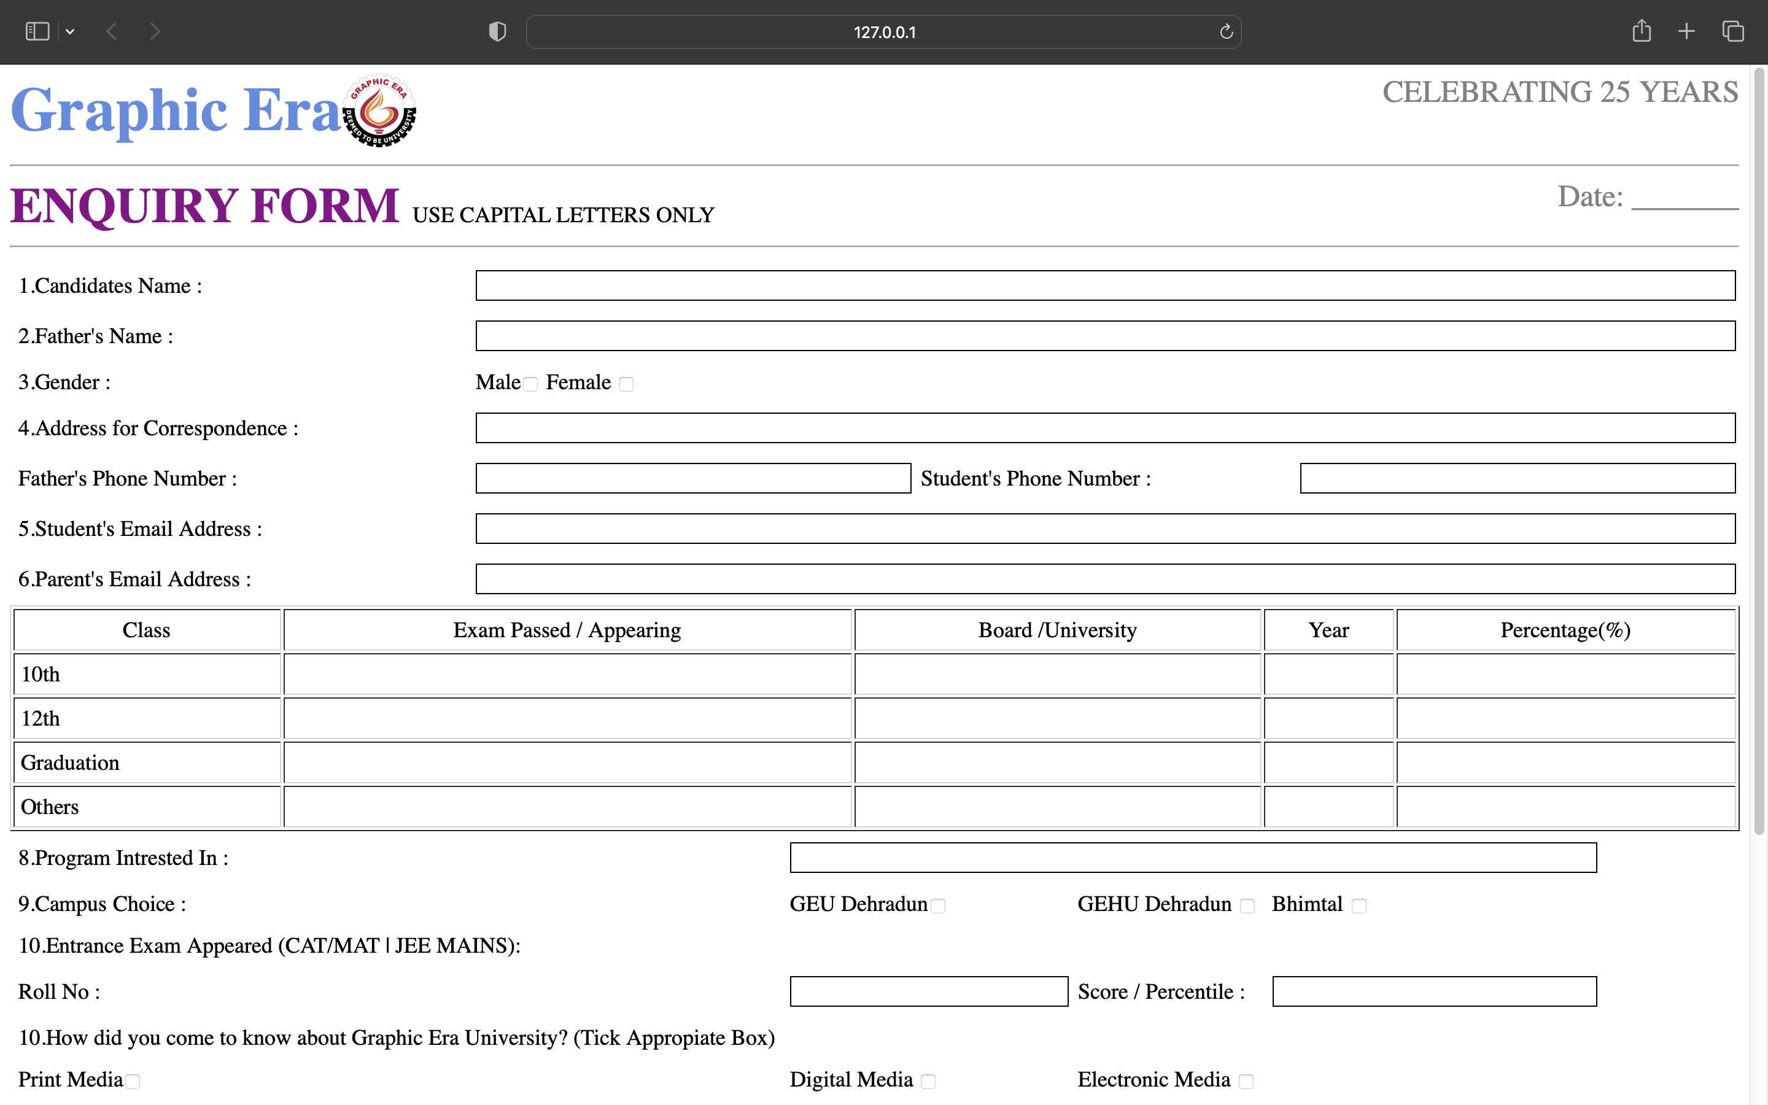

**Problem Statement 6:** A Program to design your previous semester mark sheet

**Aim:** To create Marksheet using basic HTML elements and display it on browser.

**Code:**

<html>

<head>

<title>Marksheet</title>

<style>

.studentinfo > table {

text-align: left;}

h1 {

color: green;}

.subject {

border: none;

text-align: left;}

td {

border-bottom: 0;

border-top: 0;}

table,

th,

td {

border-collapse: collapse;

font-size: large;}

.centertext {

text-align: center;

}

</style>

</head>

<body>

<img src="logo.png" height="100px" />

<br />

<h1 align="center">STATEMENT OF GRADES</h1>

<h3 align="center">

BSC - INFORMATION TECHNOLOGY - IV SEMESTER EXAMINATION(2021-22)

</h3>

<br />

<div class="studentinfo">

<table width="100%">

<tr>

<th>Name of Student:</th>

<td>Gautam Sharma</td>

<th>Father's Name':</th>

<td>Rajpati Sharma</td>

</tr>

<tr>

<th>Enrollment No:</th>

<td>20220617</td>

<th>University Roll No :</th>

<td>2200617</td>

</tr>

</table>

</div>

<br />

<table width="100%" border="1">

<tr>

<th width="70%">Code & Title Of Courses</th>

<th width="5%">Number Of Credits</th>

<th width="5%">Grade</th>

<th width="5%">Grade Point</th>

</tr>

<tr>

<th align="left" style="border: none" class="subject">Theory</th>

<td></td>

<td></td>

<td></td>

</tr>

<tr>

<td class="subject">TBI 401 JAVA Programming</td>

<td class="centertext">3</td>

<td class="centertext">A+</td>

<td class="centertext">9</td>

</tr>

<tr>

<td class="subject">TBI 402 Data Warehousing and Mining</td>

<td class="centertext">3</td>

<td class="centertext">A+</td>

<td class="centertext">9</td>

</tr>

<tr>

<td class="subject">

TBI 403 Data Communications and Computer Networks

</td>

<td class="centertext">3</td>

<td class="centertext">A+</td>

<td class="centertext">9</td>

</tr>

<tr>

<td class="subject">

TBI 404 Computer Based Numerical and Statistical Techniques

</td>

<td class="centertext">4</td>

<td class="centertext">A+</td>

<td class="centertext">9</td>

</tr>

<tr>

<td class="subject">

TBI 405 Project Management and Quality Assurance

</td>

<td class="centertext">3</td>

<td class="centertext">A+</td>

<td class="centertext">9</td>

</tr>

<tr>

<td class="subject">TBI 406 Career Skill I</td>

<td class="centertext">3</td>

<td class="centertext">A+</td>

<td class="centertext">9</td>

</tr>

<tr>

<th align="left" style="border: none" class="subject">Practical</th>

<td></td>

<td></td>

<td></td>

</tr>

<tr>

<td class="subject">PBI 401 JAVA Programming LAB</td>

<td class="centertext">2</td>

<td class="centertext">A+</td>

<td class="centertext">9</td>

</tr>

<tr>

<td class="subject">

TBI 404 Computer Based Numerical and Statistical Techniques LAB

</td>

<td class="centertext">2</td>

<td class="centertext">A+</td>

<td class="centertext">9</td>

</tr>

<tr>

<td class="subject">Seminar</td>

<td class="centertext">1</td>

<td class="centertext">A+</td>

<td class="centertext">9</td>

</tr>

<tr>

<td class="subject">General Proficiency</td>

<td class="centertext">1</td>

<td class="centertext">A+</td>

<td class="centertext">9</td>

</tr>

</table>

<br />

<div class="studentinfo">

<table width="20%">

<tr>

<th>Result:</th>

<td>Pass</td>

</tr>

<tr>

<th>Total No. of Credits registered:</th>

<td>24</td>

</tr>

<tr>

<th>Total No. of Credits Earned :</th>

<td>24</td>

</tr>

<tr>

<th>SGPA:</th>

<td>9</td>

</tr>

</table>

</div>

</body>

</html>

Output :

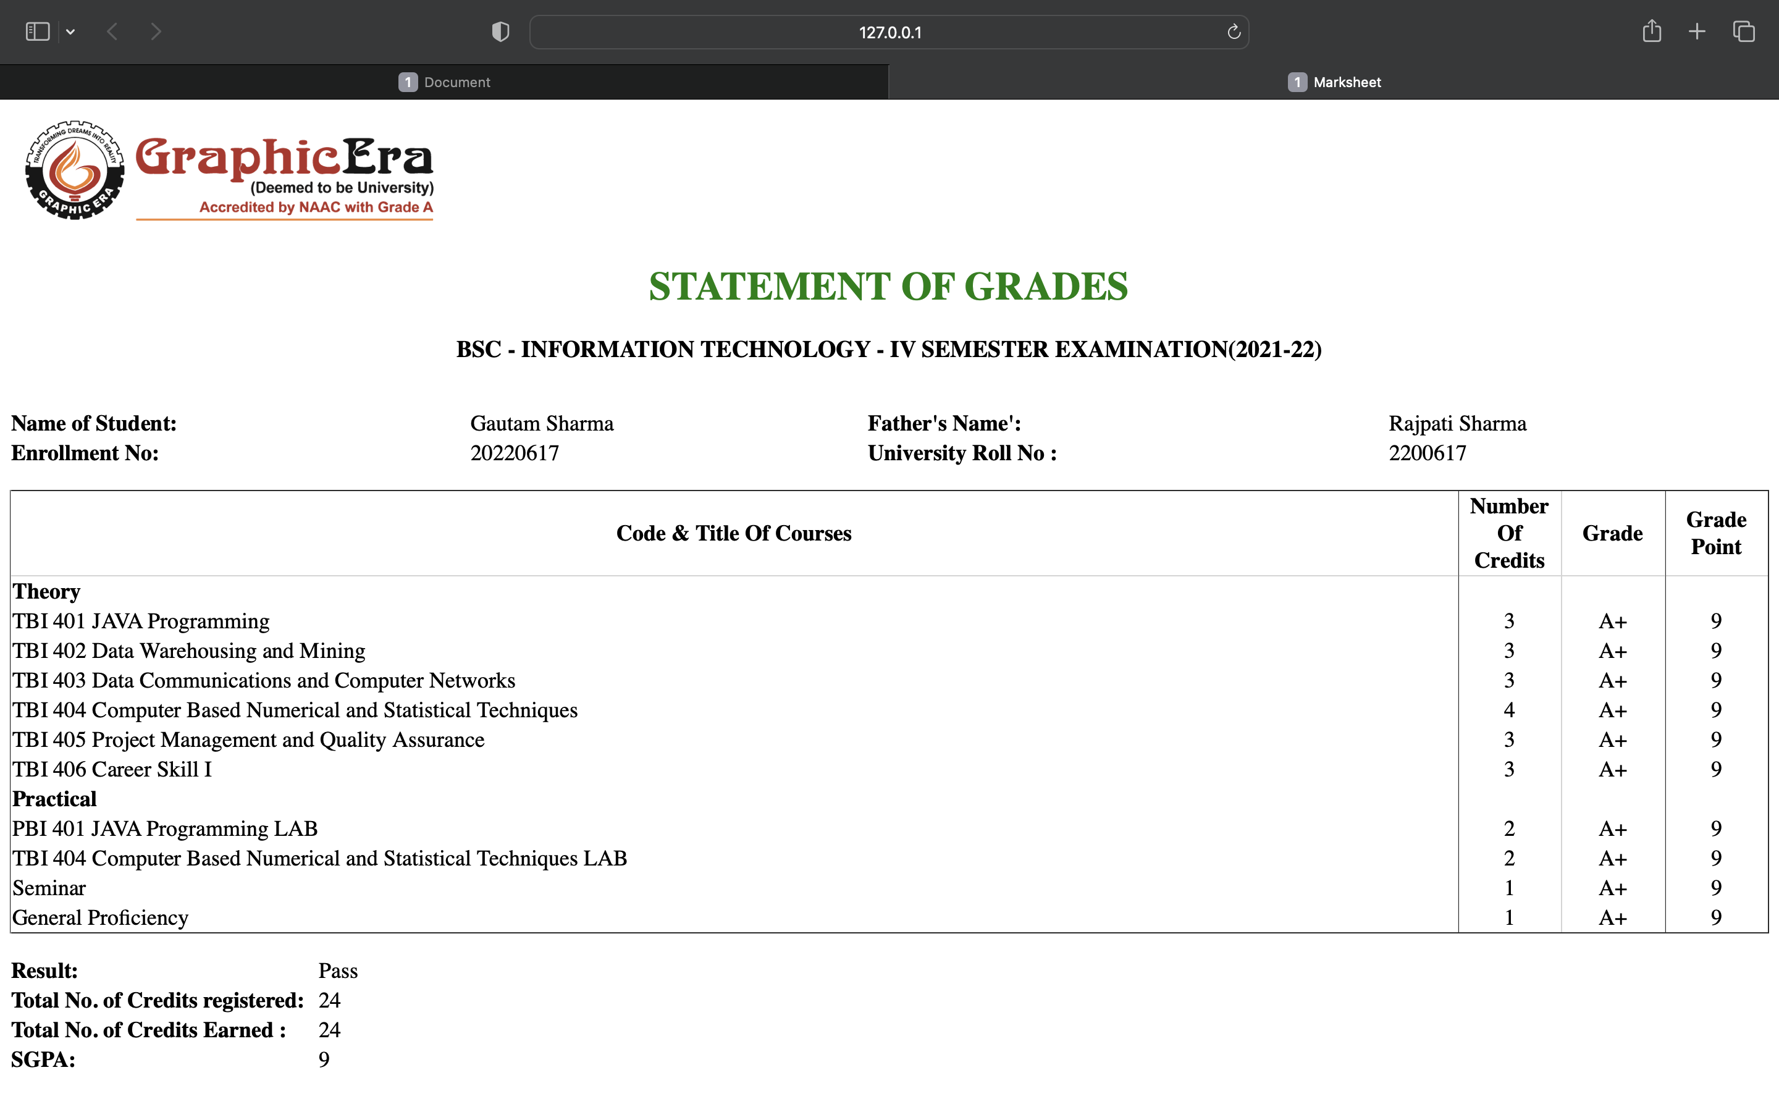

**Problem Statement 7:** A Program to implement pseudo elements in HTML.

**Aim:** To show the use of pseudo element in HTML/CSS like first-line or first word.

**Code:**

<!DOCTYPE html>

<html lang="en">

<head>

<meta charset="UTF-8" />

<meta http-equiv="X-UA-Compatible" content="IE=edge" />

<meta name="viewport" content="width=device-width, initial-scale=1.0" />

<title>Document</title>

</head>

<style>

* {

font-size: 40px;

}

.word::first-letter {

font-size: 60px;

}

.line::first-line {

color: red;

}

</style>

<body>

<p class="word">

As you can see the first letter of this paragraph is large and it is

selected by pseudo element [first-letter] CSS selector.

</p>

<p class="line">

As you can see the first line of this paragraph is of red color <br />It

is also selected by pseudo element [first-line] CSS selector.

</p>

</body>

</html>

**Output:**

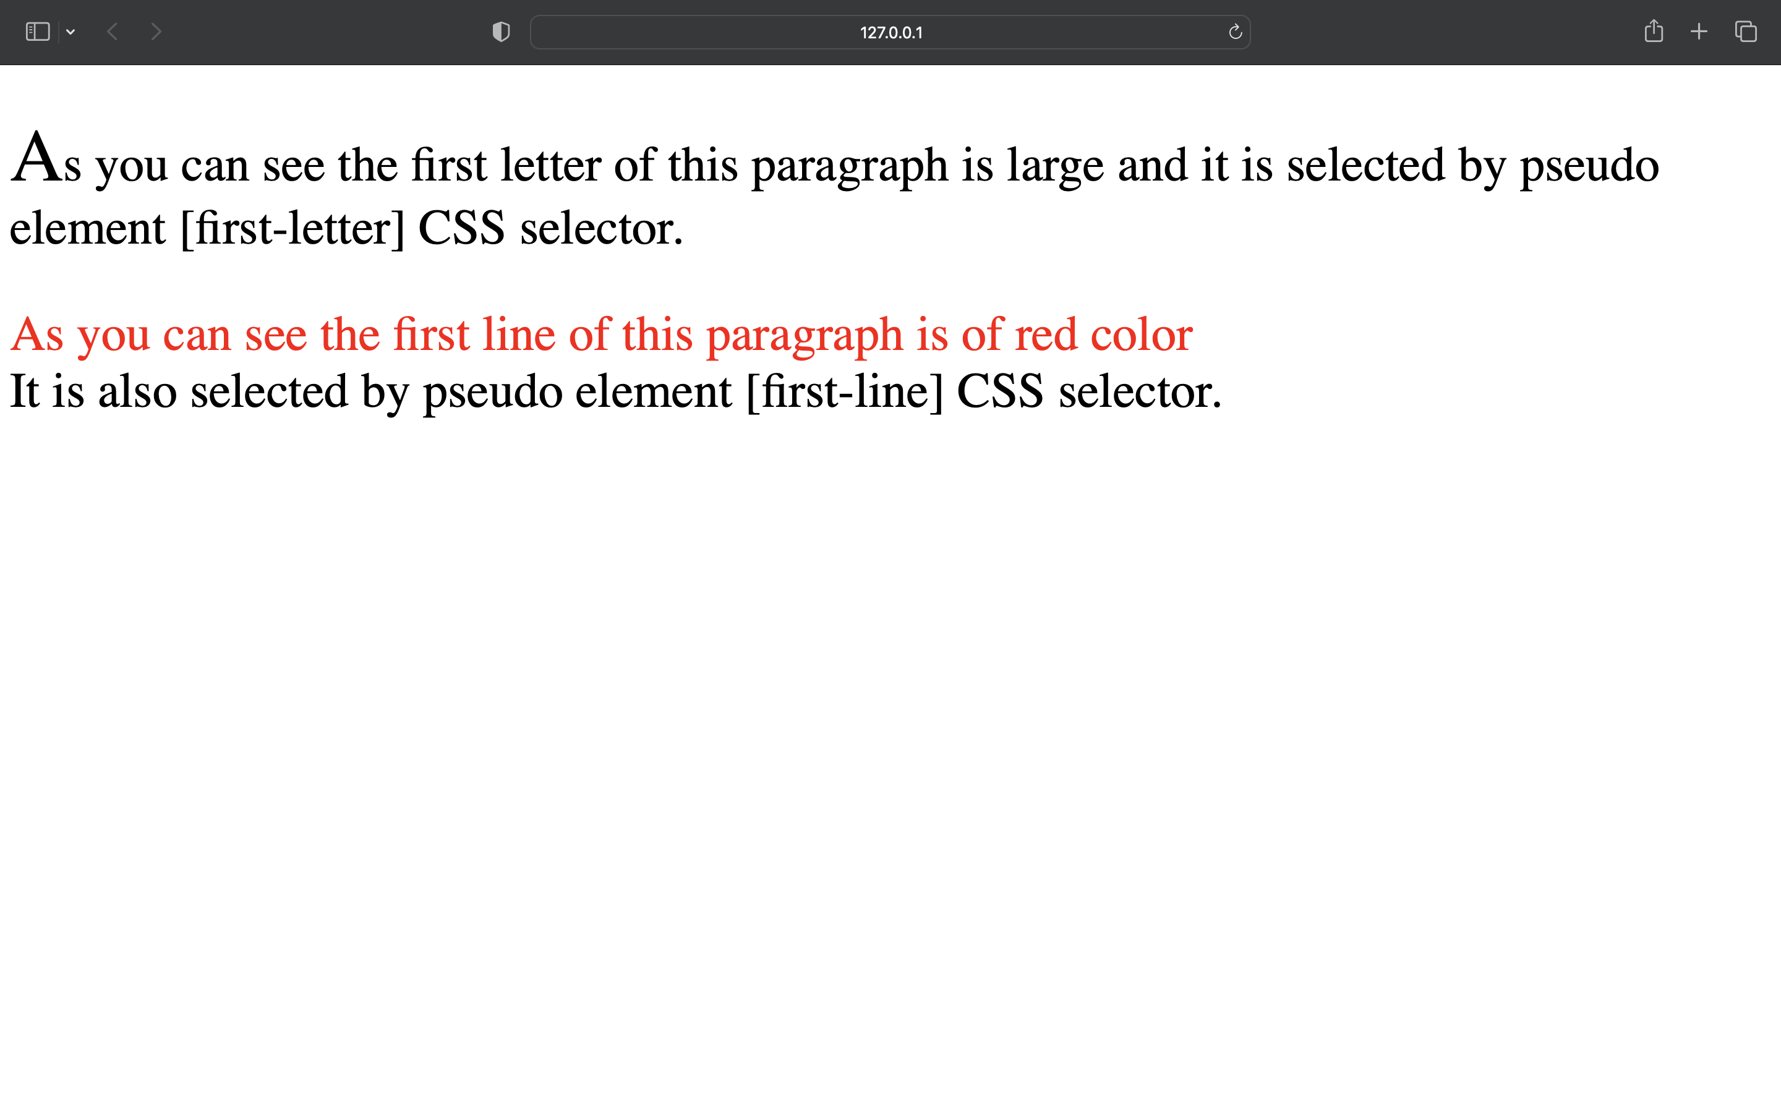

**Problem Statement 8:** A Program to implement following CSS properties in HTML

a. CSS Background

b. CSS Padding

c. Word wrap

d. White Space

**Aim:** To change background using CSS Background property and also show the use of CSS padding, Word Wrap and White Spaces.

**Code:**

<html>

<head>

<style>

body {

background-image: linear-gradient(to right, #fc4a1a, #f7b733);

}

.padd {

padding: 50px;

border: 4px solid black;

}

.nw {

white-space:nowrap;

}

.nrml {

word-wrap:normal;

}

.pre {

white-space:pre;

}

p{

color: cornsilk;

font-size: larger;

}

</style>

</head>

<body>

<h1>This Page Contains Gradient Background.</h1>

</br>

</br>

<h2>This Container has Padding of 50px.</h2>

<div class="padd">

<p>Lorem ipsum, dolor sit amet consectetur adipisicing elit. Vitae dignissimos recusandae vel natus illum tenetur id, ab sint repellendus, magni nostrum. Cum sit, laudantium velit earum consequatur minus necessitatibus amet!</p>

</div>

</br>

<h2>White space nowrap: Property</h2>

<p class="nw">

Lorem ipsum dolor sit amet consectetur adipisicing elit. Labore laborum eius facere fugiat odit. Alias veniam at itaque corporis provident, est nam repudiandae odio molestiae.

</p>

<h2>White space normal: Property</h2>

<p class="nrm">

Lorem ipsum dolor sit amet consectetur adipisicing elit. Labore laborum eius facere fugiat odit. Alias veniam at itaque corporis provident, est nam repudiandae odio molestiae.

</p>

<h2>White space pre: Property</h2>

<p class="pre">

Lorem ipsum dolor sit amet consectetur adipisicing elit. Labore laborum eius facere fugiat odit. Alias veniam at itaque corporis provident, est nam repudiandae odio molestiae.

</p>

</body>

</html>

**Output:**

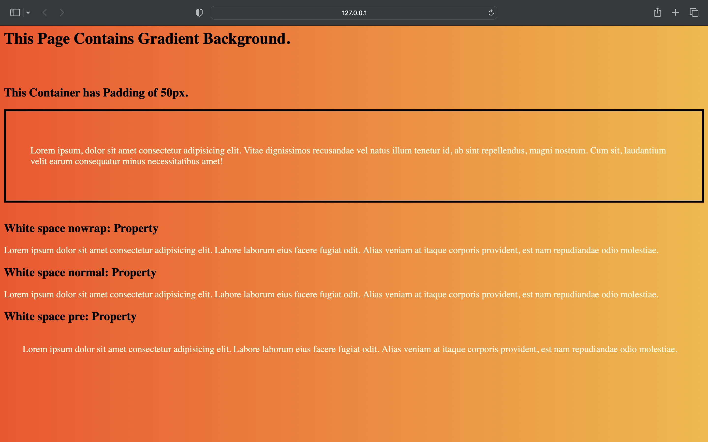

**Problem Statement 9:** A Program to implement display property using external CSS.

**Aim:** To display necessary display properties in CSS.

**Code:**

<!DOCTYPE html>

<html lang="en">

<head>

<meta charset="UTF-8">

<meta http-equiv="X-UA-Compatible" content="IE=edge">

<meta name="viewport" content="width=device-width, initial-scale=1.0">

<title>Document</title>

<link rel="stylesheet" href="ques9style.css">

</head>

<body>

<h4>This container is inline</h4>

<div id="p1">

<span>Object 1</span>

<span>Object 2</span>

<span>Object 3</span>

</div>

<br><br>

<h4>This container is block.</h4>

<div id="p2">

<span>Object 1</span>

<span>Object 2</span>

<span>Object 3</span>

</div>

<br><br>

<h4>This container is inline-block.</h4>

<div id="p3">

<span>Object 1</span>

<span>Object 2</span>

<span>Object 3</span>

</div>

<br><br>

<h4>This container is grid.</h4>

<div id="p4">

<span>Object 1</span>

<span>Object 2</span>

<span>Object 3</span>

</div>

<br><br>

</body>

</html>

**Output:**

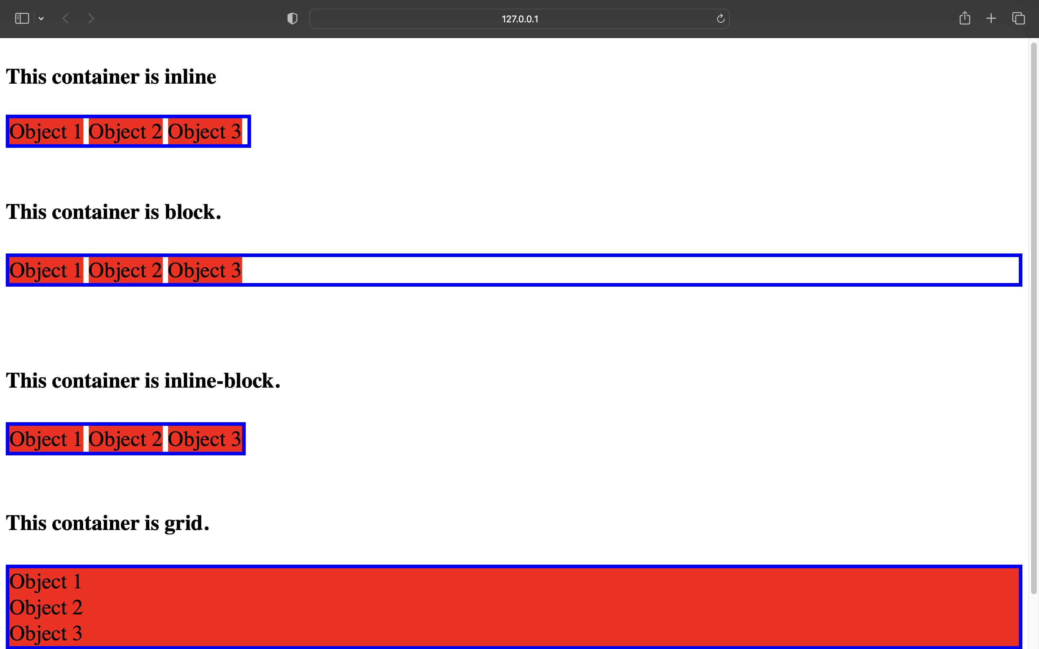

**Problem Statement 10:** A Program to implement float and visibility property using internal css.

**Aim:** To show the use of Float and Visibility property in CSS.

**Code:**

<!DOCTYPE html>

<html lang=”en”>

<head>

<meta charset=”UTF-8”>

<meta http-equiv=”X-UA-Compatible” content=”IE=edge”>

<meta name=”viewport” content=”width=device-width, initial-scale=1.0”>

<title>Document</title>

</head>

<style>

#right1 {

float:right;

}

#left1{

float:left;

}

#n1{

visibility: hidden;

}

#new{

border: 2px solid blue;

}

</style>

<body>

<p>

<img src=”a.jpeg” alt=”Good Morning Friends” height=”100px” width=”100px” />

This Image is Default.

</p>

<br> <br> <br> <br> <br> <br> <br>

<p>

<img src=”a.jpeg” alt=”Good Morning Friends” height=”100px” width=”100px” id=”right1”/>

This Image is floating Right.

</p>

<br> <br> <br> <br> <br> <br> <br>

<p id=”left1”>

<img src=”a.jpeg” alt=”Good Morning Friends” height=”100px” width=”100px” id=”left1” />

This Image is floating left.

</p>

<br> <br> <br> <br> <br> <br> <br>

<p>

This paragraph is visible by default. Paragraph below is not visible because its visibility is set to hidden only container division is visible with blue border.

</p>

<div id=”new”>

<p id=”n1”>

This paragraph is hidden.

</p>

</div>

</body>

</html>

**Output:**

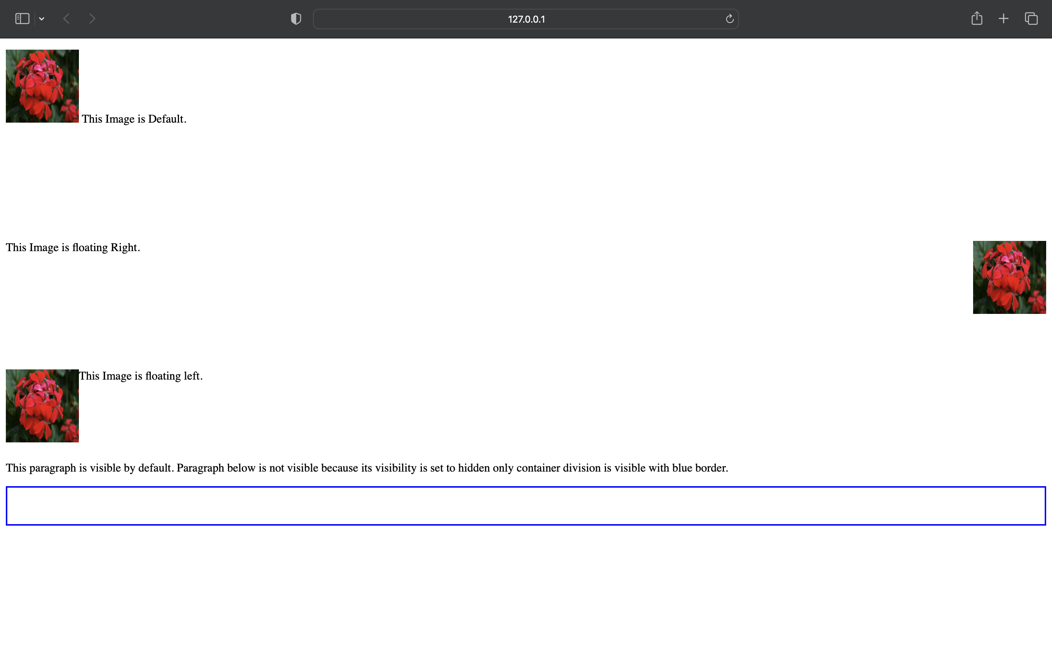

**Problem Statement 11:** A Program to design 8 paragraphs with different border style.

**Aim:** To display all border types in CSS.

**Code:**

<!DOCTYPE html>

<html lang="en">

<head>

<meta charset="UTF-8">

<meta http-equiv="X-UA-Compatible" content="IE=edge">

<meta name="viewport" content="width=device-width, initial-scale=1.0">

<title>Document</title>

</head>

<style>

*{

font-size: 40px;

}

#p1{

border-style: dashed;

}

#p2{

border-style:dotted;

}

#p3{

border-style:double;

}

#p4{

border-style:groove;

}

#p5{

border-style:inset;

}

#p6{

border-style:solid;

}

#p7{

border-style:outset;

}

#p8{

border-style:ridge;

}

</style>

<body>

<p id="p1">This is dashed paragraph border style.</p>

<p id="p2">This is dotted paragraph border style.</p>

<p id="p3">This is double paragraph border style.</p>

<p id="p4">This is groove paragraph border style.</p>

<p id="p5">This is inset paragraph border style..</p>

<p id="p6">This is solid paragraph border style.</p>

<p id="p7">This is outset paragraph border style.</p>

<p id="p8">This is ridge paragraph border style.</p>

</body>

</html>

**Output:**

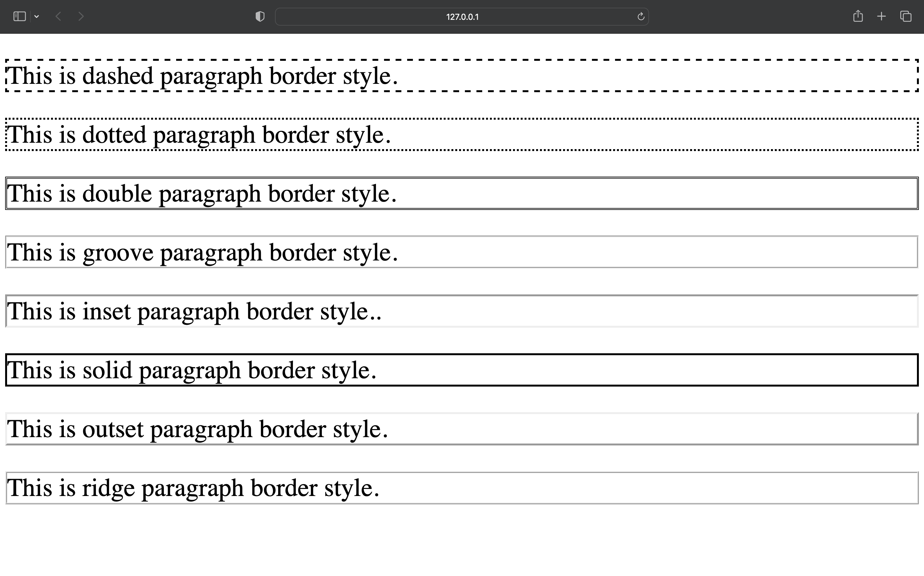

**Problem Statement 12:** Write a JavaScript code to check number is prime or not and input is taken by HTML text field.

**Aim:** To take input from user and check whether a number is prime or non-prime using JavaScript.

**Code:**

<!DOCTYPE html>

<html lang="en">

<head>

<meta charset="UTF-8" />

<meta http-equiv="X-UA-Compatible" content="IE=edge" />

<meta name="viewport" content="width=device-width, initial-scale=1.0" />

<title>Document</title>

</head>

<body>

Enter a Number :

<input type="number" id="num1" />

<input type="button" onclick="a(num1)" value="Check for Prime" />

</body>

<script>

function a(num1) {

var n = parseInt(num1.value);

var flag = -1;

for (let i = 2; i < n / 2; i++) {

if (n % i == 0) {

flag = 1;

}

}

if (flag == 1) {

alert("You entered a composite number.");

} else {

alert("You entered a prime number.");

}

}

</script>

</html>

**Output:**

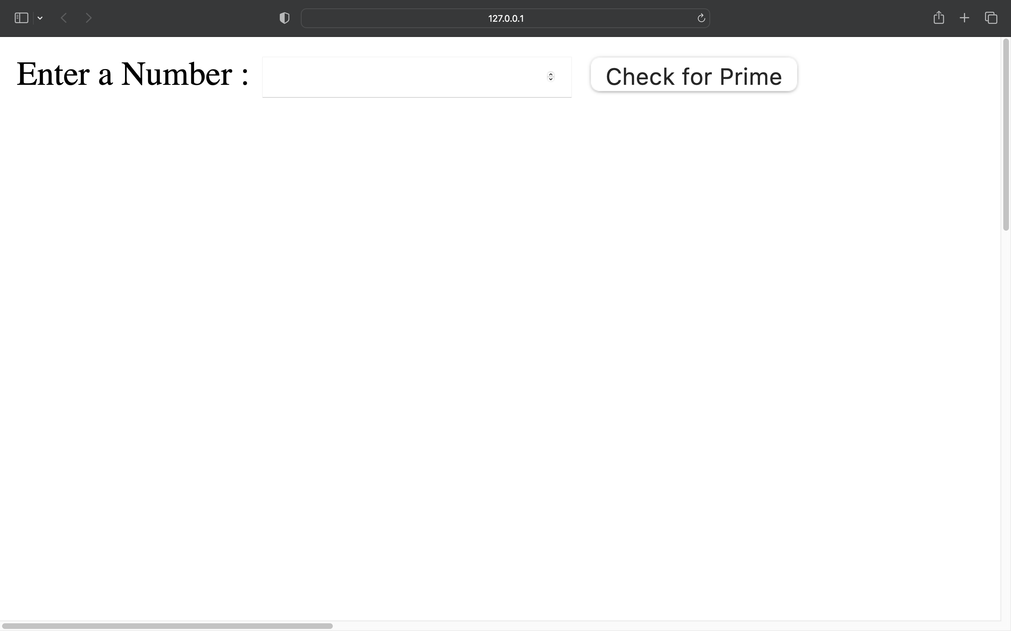

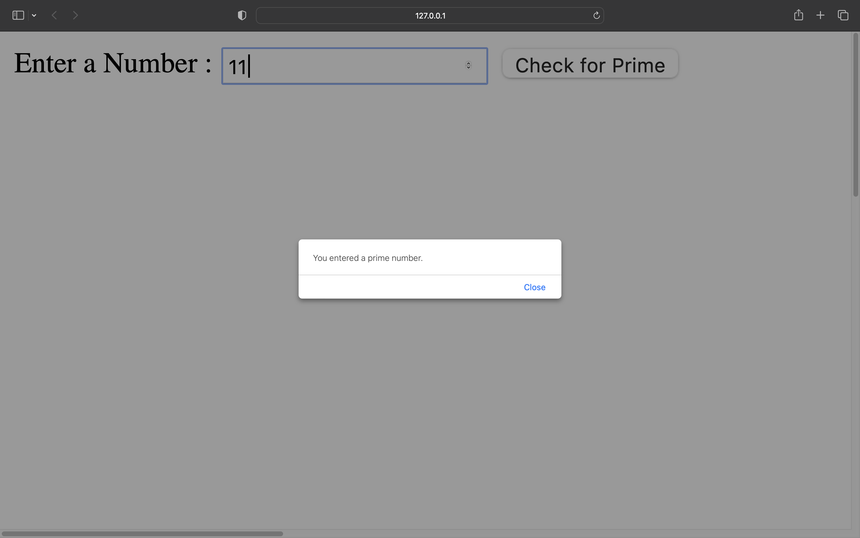

**Problem Statement 13:** Write a JavaScript code to copy one text field value into another text Field.

**Aim:** To copy the value of Text Box to another Text Box.

**Code:**

<!DOCTYPE html>

<html lang="en">

<head>

<meta charset="UTF-8">

<meta http-equiv="X-UA-Compatible" content="IE=edge">

<meta name="viewport" content="width=device-width, initial-scale=1.0">

<title>Document</title>

</head>

<body>

<form name="form1">

<label for="Textbox1">Text Box 1</label>

<input type="text" id="textbox1">

<br>

<label for="Textbox2">Text Box 2</label>

<input type="text" id="textbox2">

<br>

<button type="button" onclick="a(this.form)">Copy Values...</button>

</form>

<script>

function a(form1){

form1.textbox2.value=form1.textbox1.value;

}

</script>

</body>

</html>

**Output:**

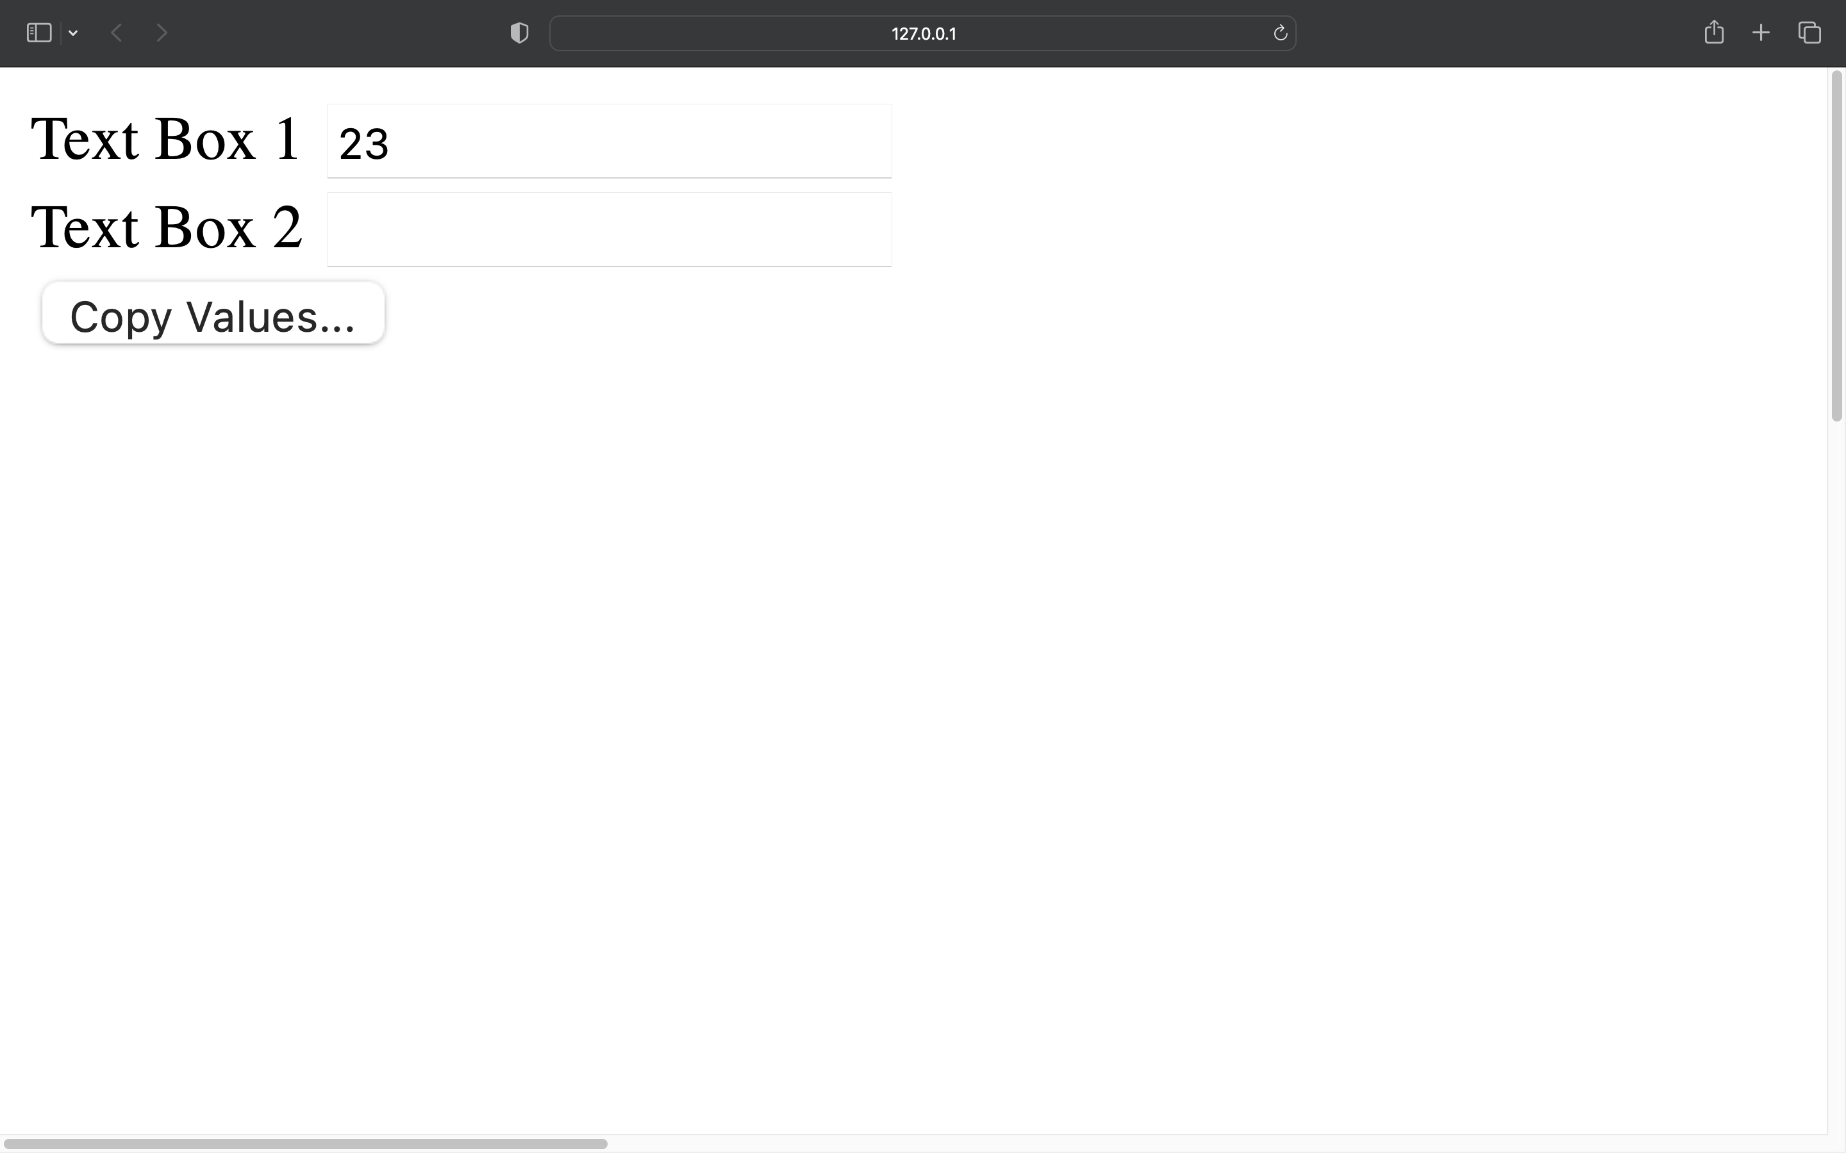

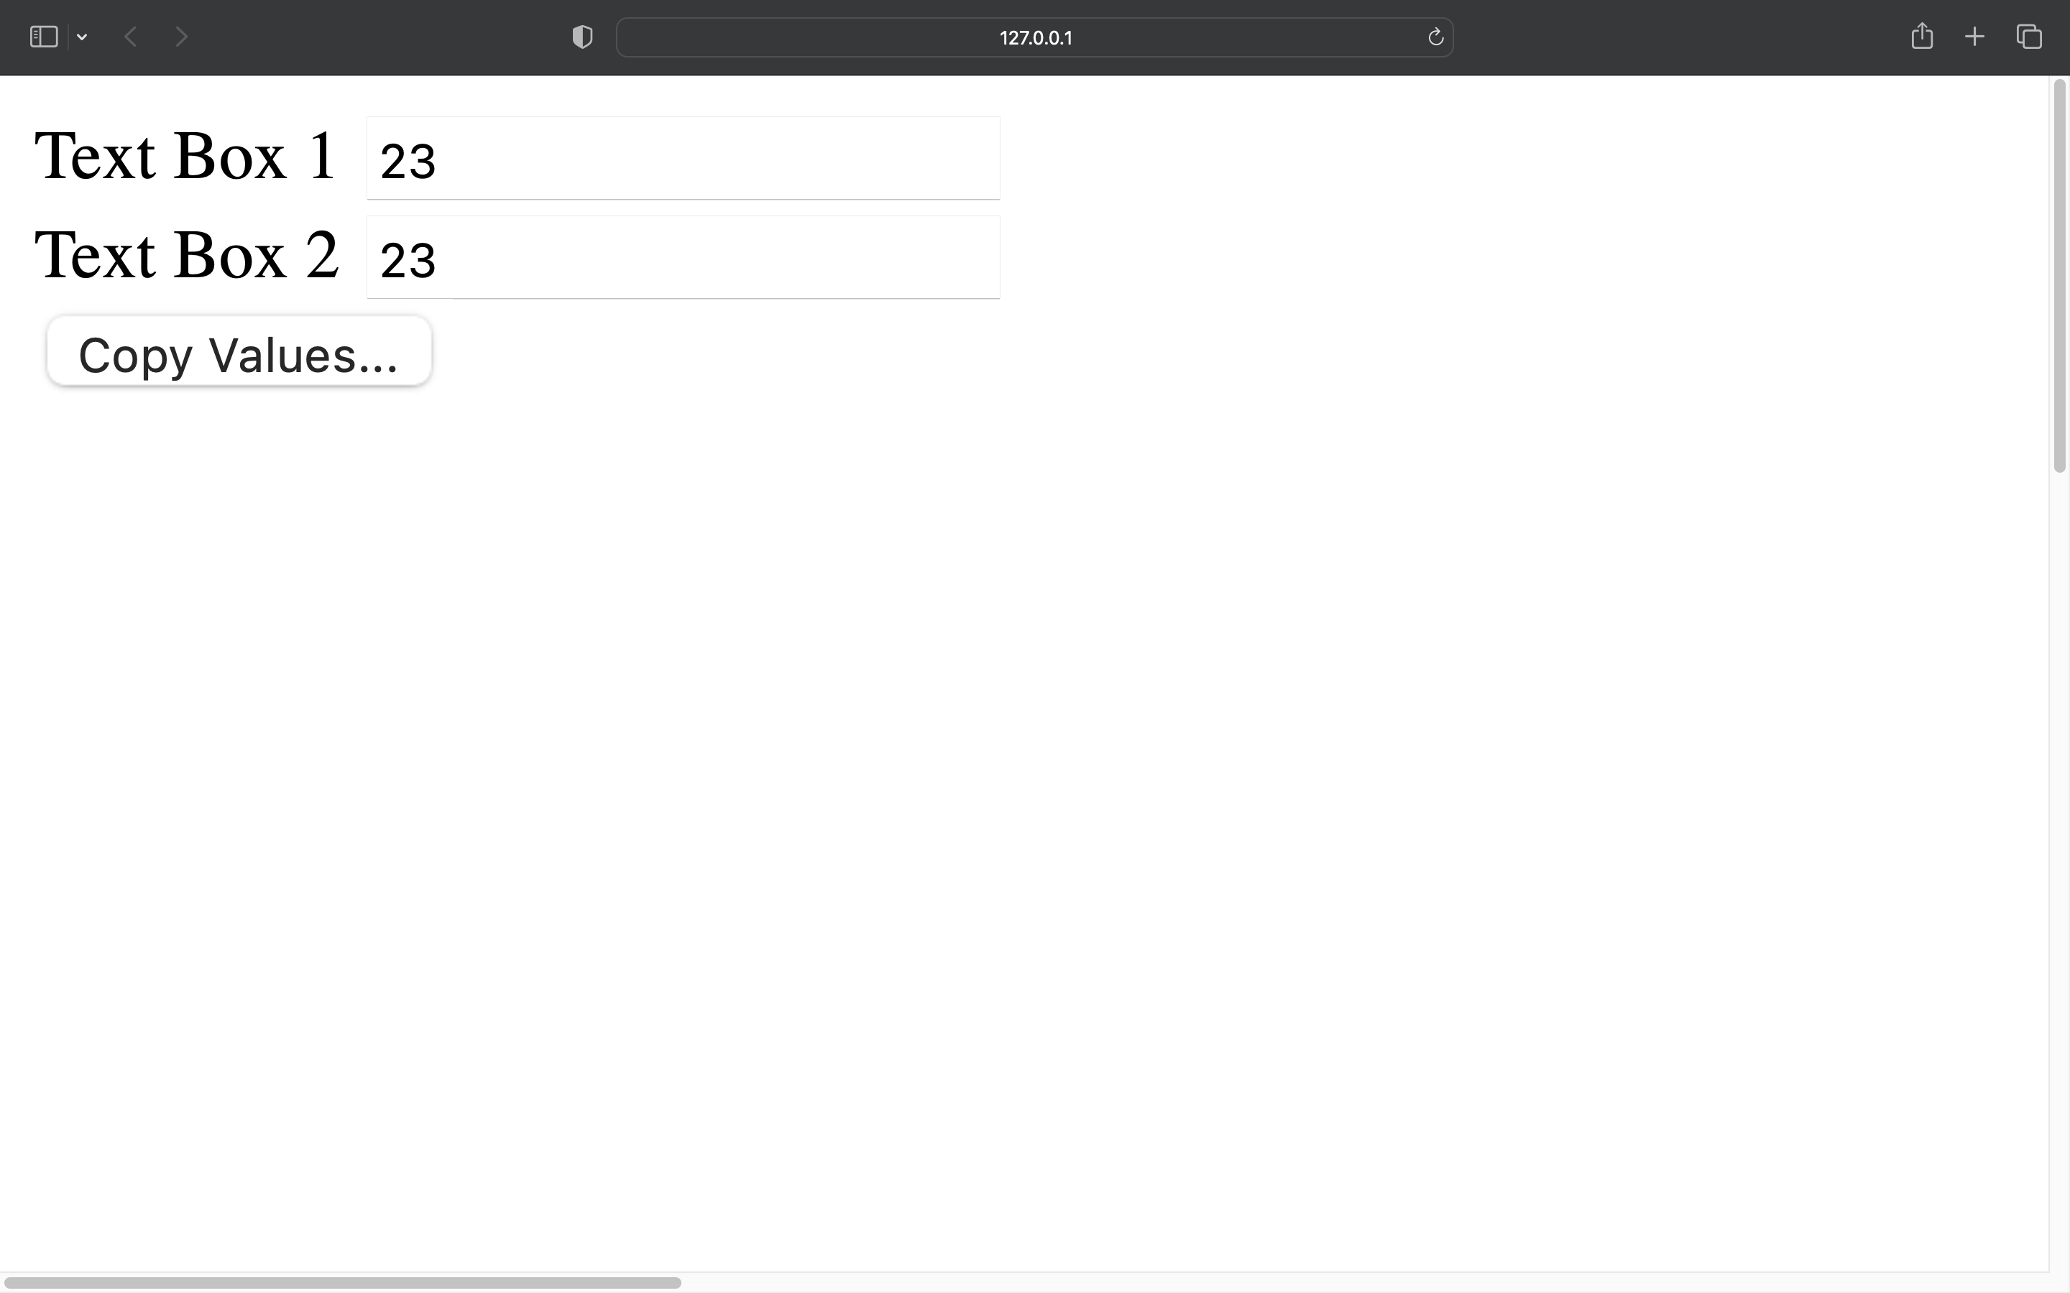

**Problem Statement 14:** Write a JavaScript code to validate whether username and password is correct or not and also validate that no field should left bank.

**Aim:** To validate the form and check whether the user has provided right credentials or not.

**Code:**

<!DOCTYPE html>

<html lang="en">

<head>

<title>Question 16</title>

</head>

<style>

body {

font-family: "Times New Roman";

font-size: 30px;

}

input {

font-size: 30px;

align: center;

}

</style>

<body>

<script>

function a() {

var user = "admin";

var password = "admin@1234";

var uname = document.getElementById("uname").value;

var pswd = document.getElementById("pswd").value;

if (uname == user && pswd == password) {

alert("Welcom admin");

} else {

alert("Wrong Credentials");

}

}

</script>

<div class="form1">

<form name="validation" onsubmit="a()">

<label for="name">Enter Username : </label>

<input type="text" id="uname" required />

<br />

<label for="Password">Enter Password : </label>

<input type="password" id="pswd" required />

<br />

<input type="submit" value="Login" />

</form>

</div>

</body>

</html>

**Output:**

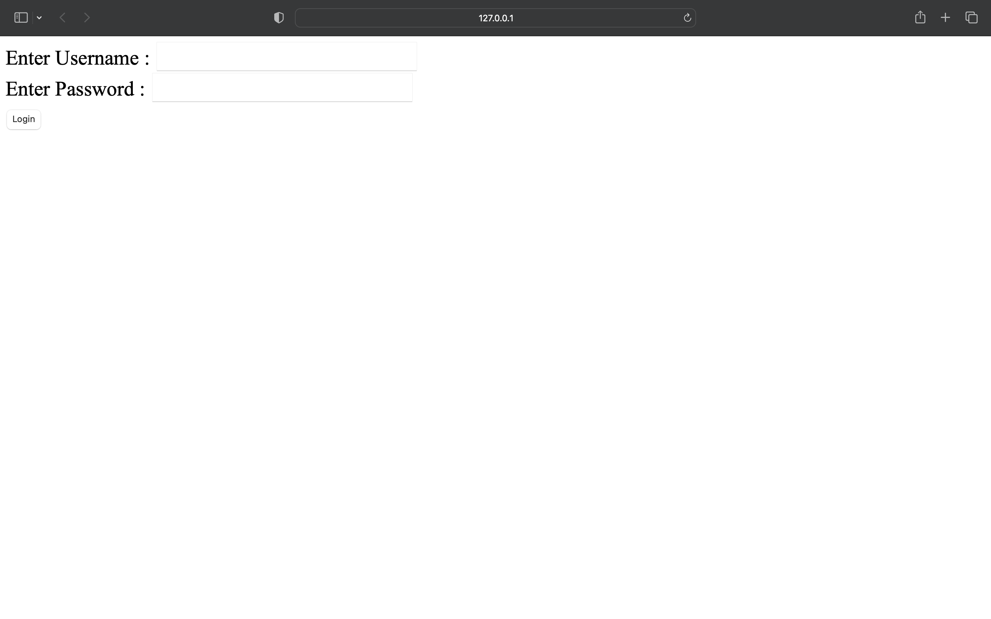

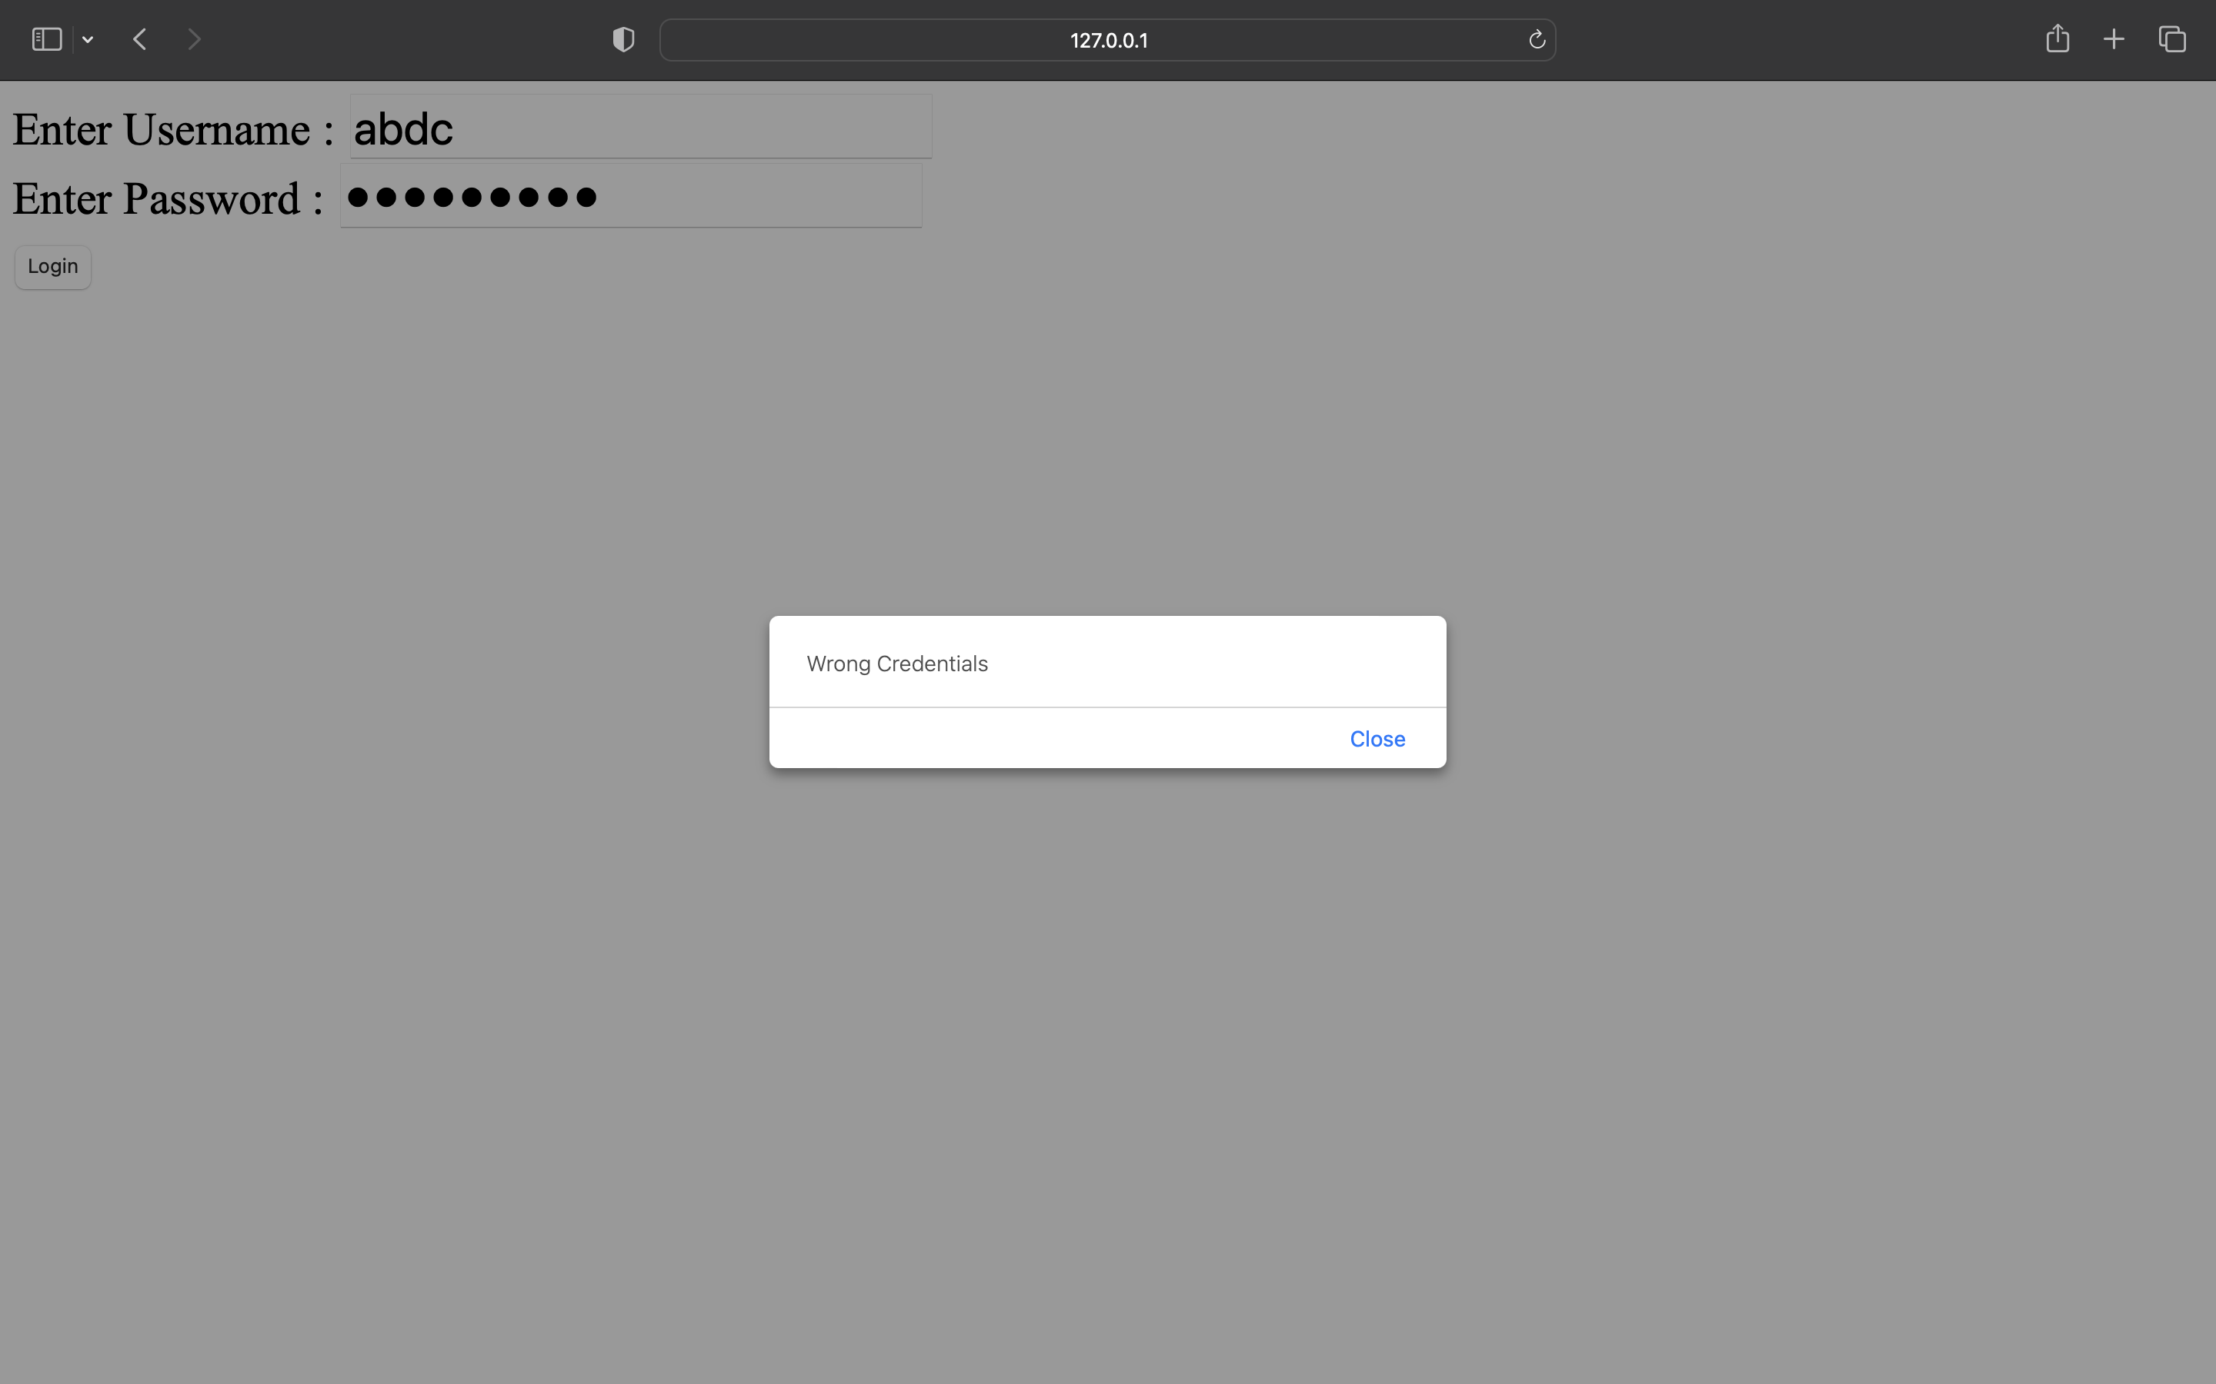

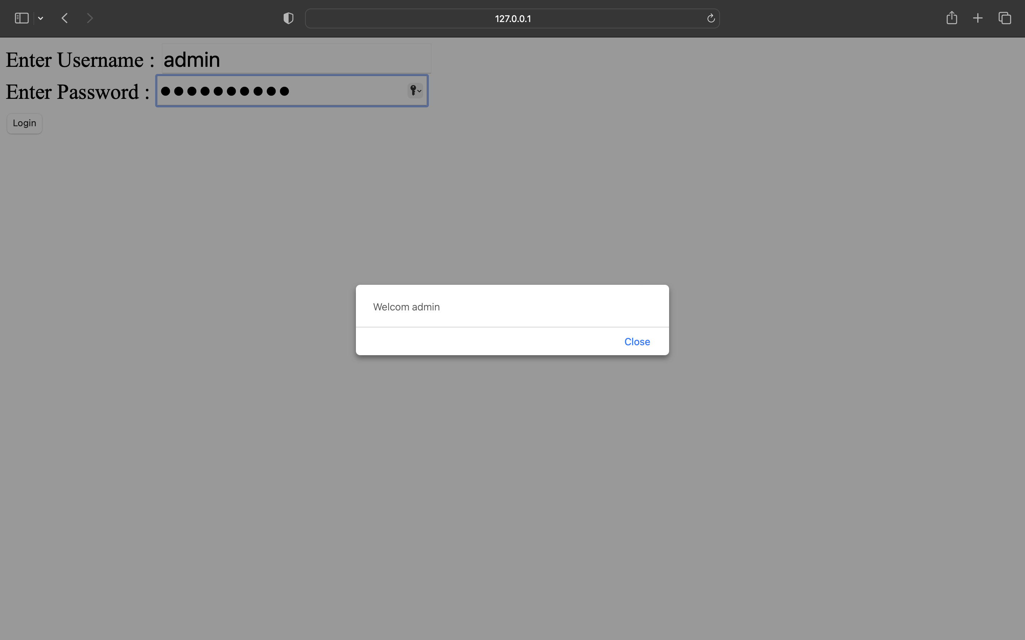

**Problem Statement 15:** Write a JavaScript code to change size of image

**Aim:** Creating a clickable image that increases size of image on click.

**Code:**

<!DOCTYPE html>

<html lang="en">

<head>

<meta charset="UTF-8">

<meta http-equiv="X-UA-Compatible" content="IE=edge">

<meta name="viewport" content="width=device-width, initial-scale=1.0">

<title>Question 17</title>

</head>

<body>

<img src="image4.jpeg" onclick="a()" id="img1" height="300px" width="300px">

<script>

function a()

{

document.getElementById("img1").style.width="500px";

document.getElementById("img1").style.height="500px";

}

</script>

</body>

</html>

**Output:**

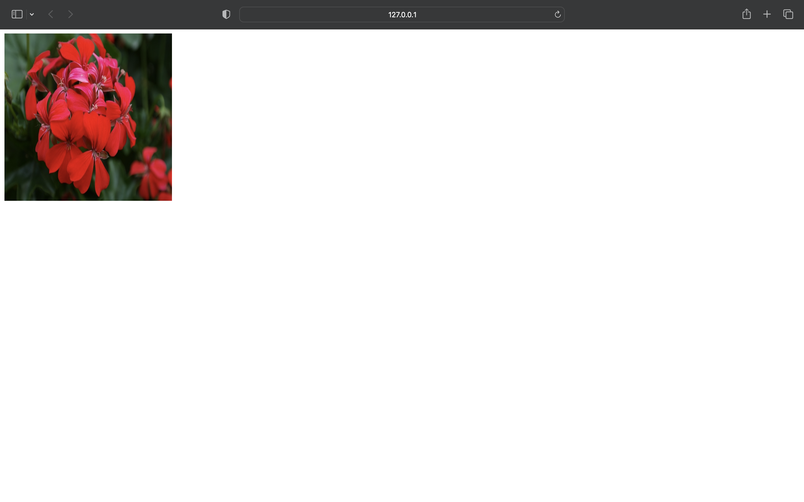

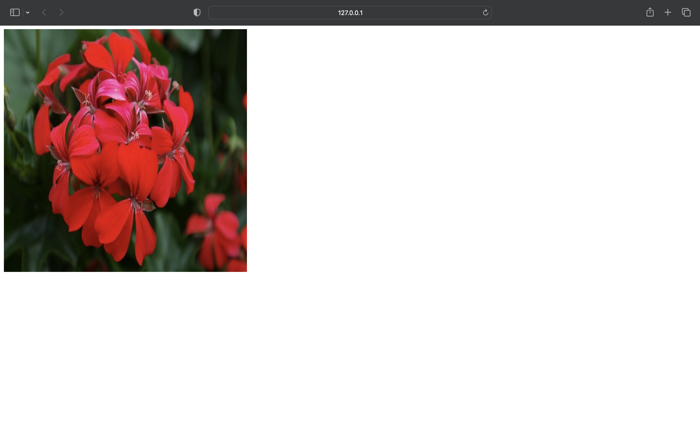**Problem Statement 16:** Write a JavaScript to change the color of a paragraph.

**Aim:** To create a button that updates color of paragraph using JavaScript function.

**Code:**

<!DOCTYPE html>

<html lang="en">

<head>

<meta charset="UTF-8">

<meta http-equiv="X-UA-Compatible" content="IE=edge">

<meta name="viewport" content="width=device-width, initial-scale=1.0">

<title>Document</title>

</head>

<style>

body{

font-family:"Times New Roman";

font-size: 30px;

}

input{

font-family:"Times New Roman";

font-size: 30px;

}

</style>

<body>

<p id="nw">Click the buuton below to change my color.</p>

<input type="button" onclick="a()" value="Click To Change Color" /> <script>

function a(){

document.getElementById("nw").style.color="red";

}

</script>

</body>

</html>

**Output:**

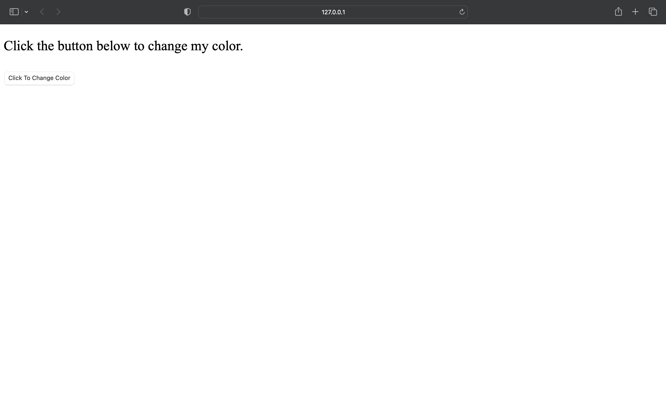

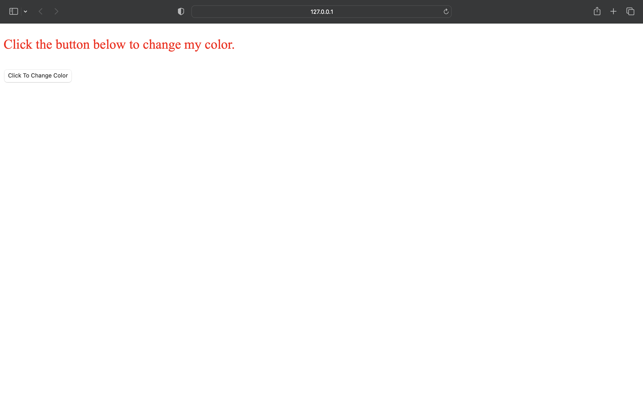

**Problem Statement 17:** Write a PHP code to save student id, name, and contact number

**Aim:** To create Database and table in mysql using PHP and insert one row that contains student ID , Name and Contact number.

**Code:**

<?php

$host = 'localhost:3306';

$user = 'root';

$pass = '';

$dbname = 'STD';

$conn = mysqli_connect($host, $user, $pass, $dbname);

if (!$conn) {

die('Could not connect: ''.mysqli_connect_error());

} else {

$sql = "INSERT INTO student(id,firstname,contact) VALUES ('101','GAUTAM','7856784987');";

if ($conn->query($sql) === TRUE) {

echo "Student Record Inserted successfully";

} else {

echo "Could not insert record: " . mysqli_error($conn);

}

}

mysqli_close($conn);

?>

**Output:**

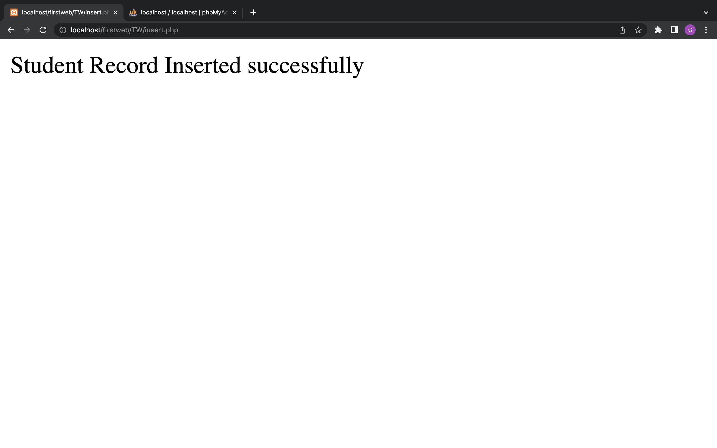

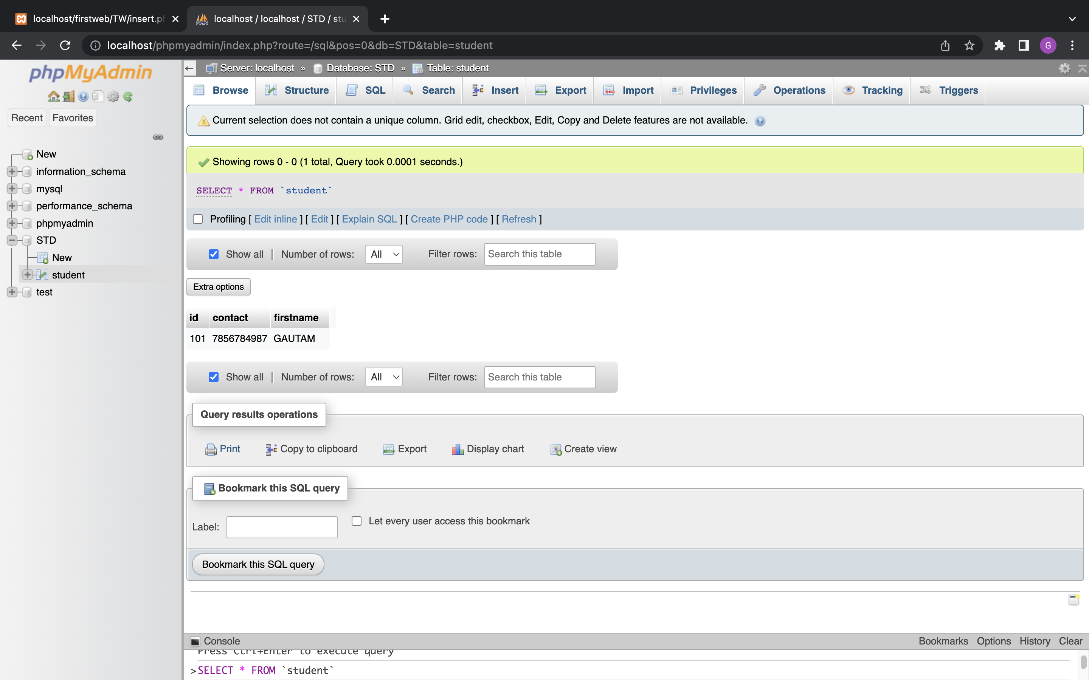

**Problem Statement 18:** Write a PHP code to update student contact number if student id=1001.

**Aim:** To update the records of student where the student ID equals 1001.

**Code:**

<?php

$host = 'localhost:3306';

$user = 'root';

$pass = '';

$dbname = 'STD';

$conn = mysqli_connect($host, $user, $pass, $dbname);

if (!$conn) {

die('Could not connect: ' . mysqli_connect_error());

} else {

$sql = "update student set contact='7789765606' where id=101;";

if ($conn->query($sql) === TRUE) {

echo "Student Record Updated successfully";

} else {

echo "Could not insert record: " . mysqli_error($conn);

}

}

mysqli_close($conn);

?>

**Output:**

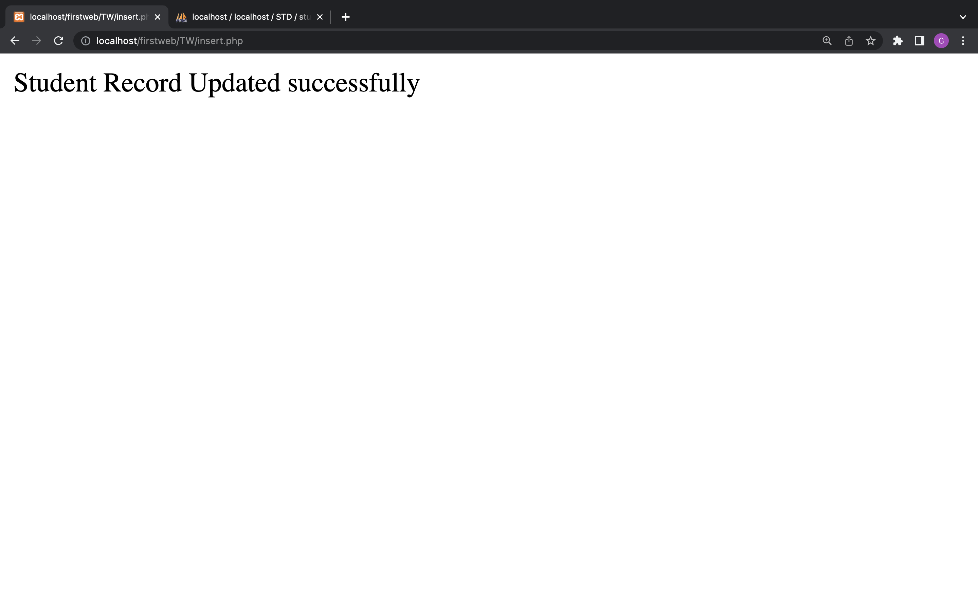

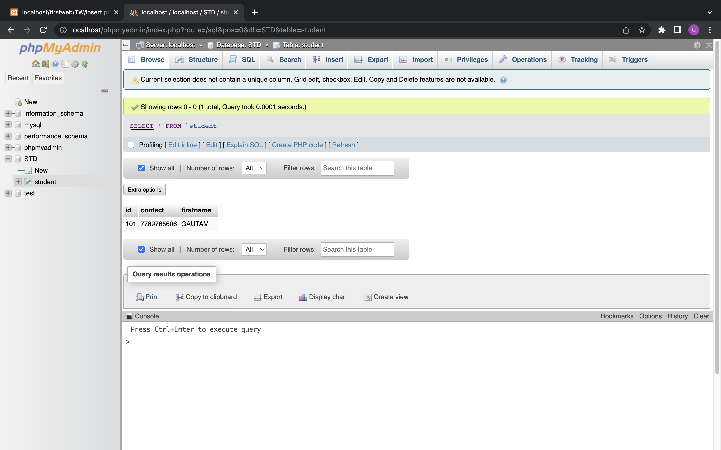

**Problem Statement 19:** Write a PHP code to retrieve all student details.

**Aim:** To display all rows stored in student column and show them on browser with appropriate tags and formatting.

**Code:**

<?php

$host = 'localhost:3306';

$user = 'root';

$pass = '';

$dbname = 'STD';

$conn = mysqli_connect($host, $user, $pass, $dbname);

if (!$conn) {

die('Could not connect: ' . mysqli_connect_error());

}

$sql = 'SELECT * FROM student';

$retval = mysqli_query($conn, $sql);

if (mysqli_num_rows($retval) > 0) {

while ($row = mysqli_fetch_assoc($retval)) {

echo "STUDENT ID :{$row['id']} <br> " .

"FIRST NAME : {$row['firstname']} <br> " .

"CONTACT : {$row['contact']} <br> " .

"--------------------------------<br>";

}

} else {

echo "NO RESULTS FOUND :/";

}

mysqli_close($conn);

**Output:**

